Table of Content

Table of Content 1
ISIS 2
Prefix Suppression 2
Hello Padding 5
Overload Bit 8
LSP Size 11
Default Metric 12
Hello/Hold Timer 14
Mesh Groups 16
Prefix Summarization 18
Default Route Preference 21
ISIS Timers 23
Log Neighbor Changes 24
Troubleshooting 1 – No routes 26
Troubleshooting 2 – Adjacency 27
Troubleshooting 3 30
IPv6 Single Topology 31
IPv6 Single Topology Challenge 32
IPv6 Multitopology 33
IPv6 Single to Multitopology 34
Wide Metrics 36
Route Filtering 38
Backdoor Link 40
Non-Optimal Intra-Area Routing 43
Multi Area 45
Authentication 1 47
Authentication 2 50
Authentication 3 52
Conditional ATT Bit 55
Troubleshoot iBGP 56
Troubleshoot TE Tunnel 59
BGP 64
Russo – Lab 1 ECMP 64
Russo – Lab 2 UCMP 67
Russo – Lab 3 Backup Path 70
Russo – Lab 4 Shadow Session 74

ISIS

Prefix Suppression
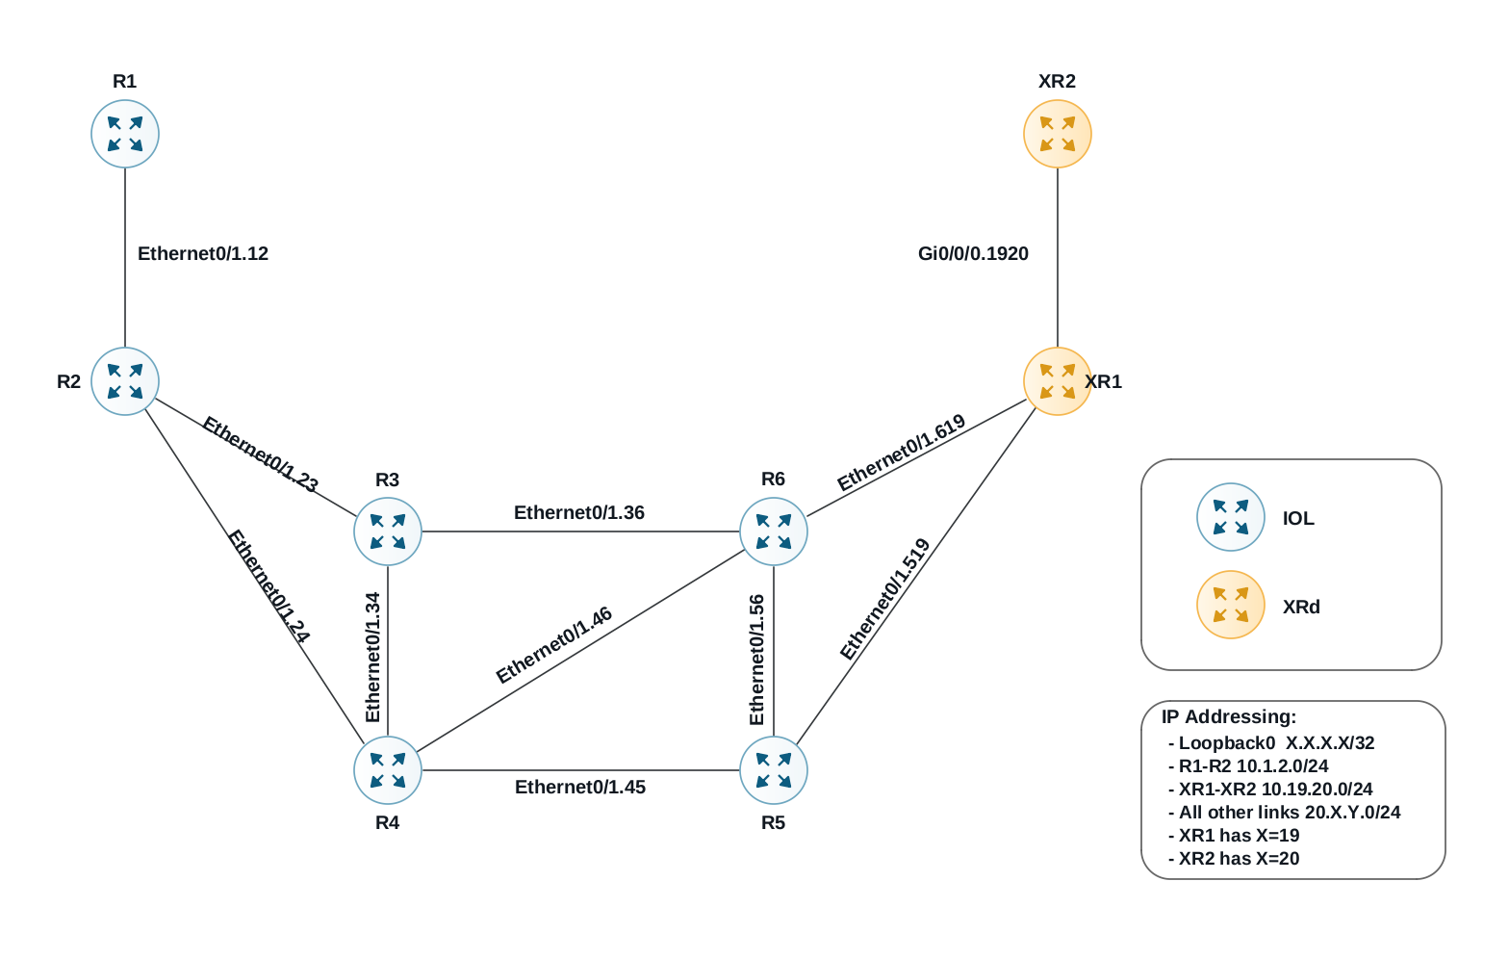

Load Config
# IOL
configure replace unix:labconfigs/isis.cfg force

# IOS-XR
configure
load config:labconfigs/isis.cfg
commit replace confirmed minutes 1
commit

- Configure ISIS so that only the loopbacks are advertised into the IGP.
- Only use interface-level commands on R2 and XR2.

Answer
# R1 – R6
router isis
advertise passive-only

# R2
interface Ethernet0/1.12
no isis advertise prefix
interface Ethernet0/1.23
no isis advertise prefix
interface Ethernet0/1.24
no isis advertise prefix

# XR1
router isis 1
address-family ipv4 unicast
advertise passive-only

# XR2
router isis 1
interface GigabitEthernet0/0/0/0.1920
suppressed

Explanation
In ISIS, the link address is not part of the underlying topology. It is simply advertised as an additional prefix in the IP reachability TLV. By configuring advertise passive-only we instruct the router to suppress all prefixes except for the passive interfaces, which in our case is only Lo0.

R1#show isis database R1.00-00 verbose

IS-IS Level-2 LSP R1.00-00
LSPID LSP Seq Num LSP Checksum LSP Holdtime/Rcvd ATT/P/OL
R1.00-00 * 0x00000003 0x3E4E 929/* 0/0/0
Area Address: 49.0001
NLPID: 0xCC
Hostname: R1
Metric: 10 IS R2.03
IP Address: 1.1.1.1
Metric: 0 IP 1.1.1.1 255.255.255.255

How does R2 have the correct nexthop for R1’s loopback? We don’t see R1 advertising its nexthop anywhere in the LSP. The answer is that R1 advertises its interface address in the Hello. This is how R2 knows what to use for the nexthop to 1.1.1.1.
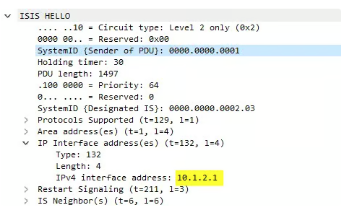

Hello Padding

Load Config
# IOL
configure replace unix:labconfigs/isis.cfg force

# IOS-XR
configure
load config:labconfigs/isis.cfg
commit replace confirmed minutes 1
commit

- Configure R1 and XR2 so that Hellos are only padded the first six times.

Answer
# R1
int Eth0/1.12
no isis hello padding
! Or
router isis
no hello padding [multi-point|point-to-point]

# XR2
router isis 1
int Gi0/0/0/0.1920
hello-padding sometimes [level 2]

Explanation
By default, the router will always pad Hellos. This can be considered an unnecessary waste of bandwidth, as once you’ve verified MTU via the padded Hellos, you no longer really need to continue to pad Hellos.
When using the above configuration, the router will only pad the first 6 Hellos. After this, all subsequent Hellos are not padded, which saves some bandwidth.
If for some reason you wanted to never pad Hellos, not even at the beginning of the adjacency, you can use no isis hello padding always under the interface on IOS-XE, or hello-padding disable on IOS-XR. This is similar to OSPF’s ip ospf mtu-ignore setting.

R1#show clns interface eth0/1.12
Ethernet0/1.12 is up, line protocol is up
Attached to: isis
Checksums enabled, MTU 1497, Encapsulation SAP
ERPDUs enabled, min. interval 10 msec.
CLNS fast switching enabled
CLNS SSE switching disabled
DEC compatibility mode OFF for this interface
Next ESH/ISH in 21 seconds
Routing Protocol: IS-IS
Circuit Type: level-1-2
Interface number 0x0, local circuit ID 0x1
Level-2 Metric: 10, Priority: 64, Circuit ID: R2.03
DR ID: R2.03
Level-2 IPv6 Metric: 10
Number of active level-2 adjacencies: 1
Next IS-IS LAN Level-2 Hello in 327 milliseconds
No hello padding

When you use no isis hello padding always, you will instead see “Never pad hello PDU”:
R1#show clns interface eth0/1.12
Ethernet0/1.12 is up, line protocol is up
Attached to: isis
Checksums enabled, MTU 1497, Encapsulation SAP
ERPDUs enabled, min. interval 10 msec.
CLNS fast switching enabled
CLNS SSE switching disabled
DEC compatibility mode OFF for this interface
Next ESH/ISH in 39 seconds
Routing Protocol: IS-IS
Circuit Type: level-1-2
Interface number 0x0, local circuit ID 0x1
Level-2 Metric: 10, Priority: 64, Circuit ID: R2.03
DR ID: R2.03
Level-2 IPv6 Metric: 10
Number of active level-2 adjacencies: 1
Next IS-IS LAN Level-2 Hello in 8 seconds
Never pad hello PDU

On IOS-XR.
RP/0/RP0/CPU0:XR2#show isis interface gigabitEthernet 0/0/0/0.1920
Thu Oct 22 01:51:22.590 UTC

GigabitEthernet0/0/0/0.1920 Enabled
Adjacency Formation: Enabled
Prefix Advertisement: Enabled
Bandwidth: 1000000
RSI SRLG: Not Registered

Circuit Type: level-2-only (Configured: level-1-2)
Media Type: LAN
Circuit Number: 7
Last IIH Received: 01:51:22 (0.31 sec ago), 1497 octets
Last PDU Rejected: 01:16:01 (00:35:20 ago), 101 octets, L2 LSP, Wrong Adjacency State
Last IIH Sent: 01:51:20 (2.34 sec ago), 55 octets

XR2 sent Hello without Padding (55 octets), whilst its neighbor (XR1) sent padded Hello (1497 octets).

Overload Bit

Load Config
# IOL
configure replace unix:labconfigs/isis.cfg force

# IOS-XR
configure
load config:labconfigs/isis.cfg
commit replace confirmed minutes 1
commit

Set the overload bit on routers R2, R3, and XR1:
- On R2, set overload bit on startup, wait for BGP, and supress all external routes
- On R3, set overload bit right now, and advertise all prefixes
- On XR1, set overload bit on startup, wait for BGP, and suppress both inter-area and external routes

Answer

# R2
router isis
set-overload-bit on-startup wait-for-bgp suppress external

# R3
router isis
set-overload-bit

# XR1
router isis 1
set-overload-bit on-startup wait-for-bgp

Explanation

XR1, we can verify overload bit configuration using show isis protocol.
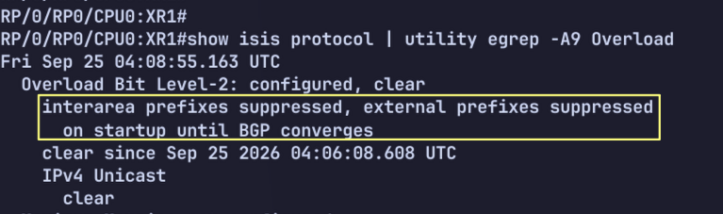

R3 is currently setting the OL bit in its LSP:
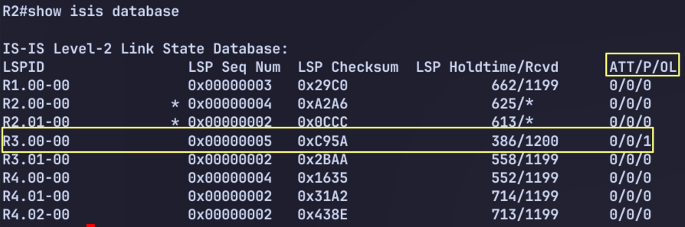
Note that when the OL bit is set, the router is never used for transit, even if no other paths exist. The node can still be used to reach leaf prefixes advertised directly from the node itself, such as its own loopback.

R2 should no longer have ECMP routes to XR1. It should only be using R4 for transit. It will only use R3 for traffic R3 itself is advertising - its loopback and connected routes.
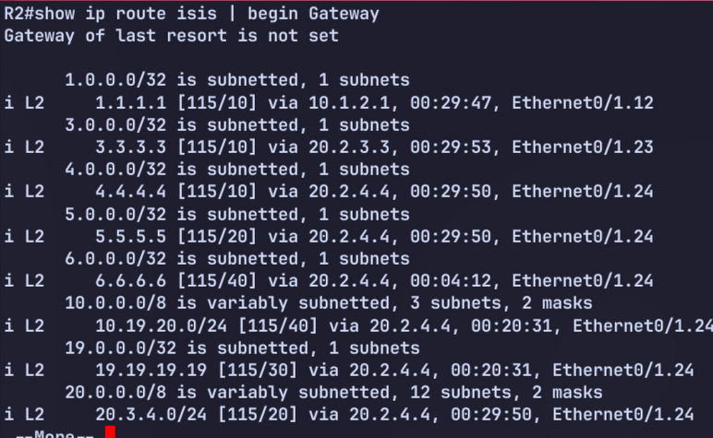
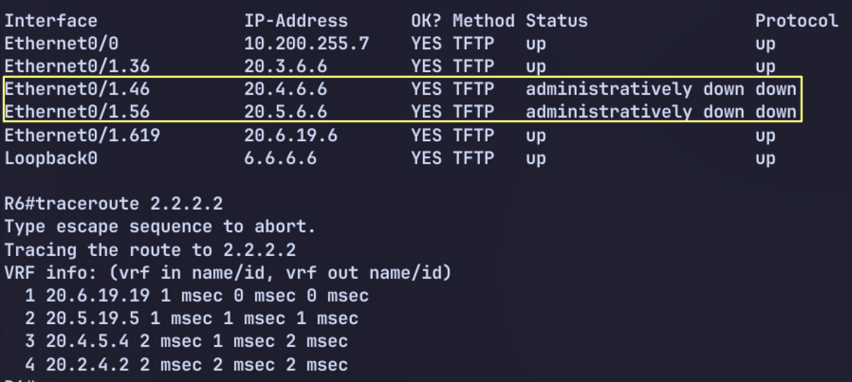

LSP Size
Figure 0-1 ISIS Single Area

Load Config
# IOL
configure replace unix:labconfigs/isis.cfg force

# IOS-XR
configure
load config:labconfigs/isis.cfg
commit replace confirmed minutes 1
commit

- Enable wide metrics everywhere.
- Configure R1 and XR2 so that their LSP is fragmented once is it bigger than 128 bytes.

Answer

# IOL
router isis
metric-style wide

# IOS-XR
router isis 1
address-family ipv4 unicast
metric-style wide

# R1
router isis
lsp-mtu 128

# XR2
router isis 1
lsp-mtu 128

Explanation

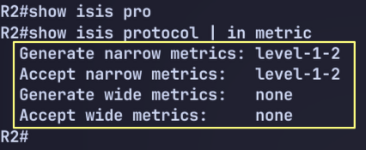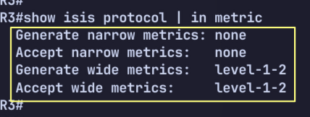

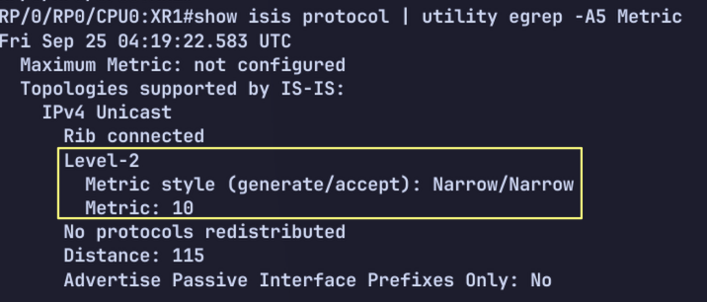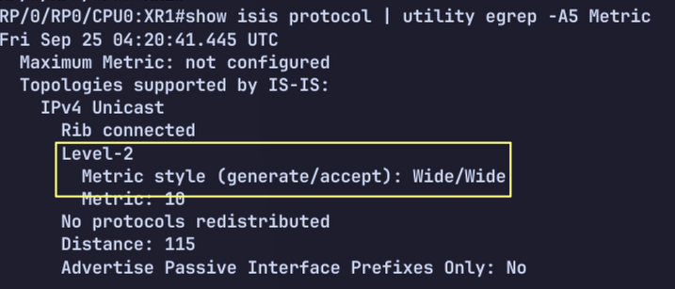
By default, an LSP is fragmented at 1500 bytes. We can control this by setting the lsp-mtu. When the router’s own LSP becomes larger than the specified MTU size, it is split into multiple LSPs.

Default Metric

Load Config
# IOL
configure replace unix:labconfigs/isis.cfg force

# IOS-XR
configure
load config:labconfigs/isis.cfg
commit replace confirmed minutes 1
commit

- Configure all routers so that the default metric is 100.

Answer

# IOL
router isis
metric-style wide
metric 100

# IOS-XR
router isis 1
address-family ipv4 unicast
metric-style wide
metric 100

Explanation
# R1
R1#show isis topology

IS-IS TID 0 paths to level-2 routers
System Id Metric Next-Hop Interface SNPA
R1 --
R2 100 R2 Et0/1.12 aabb.cc00.0210
R3 200 R2 Et0/1.12 aabb.cc00.0210
R4 200 R2 Et0/1.12 aabb.cc00.0210
R5 300 R2 Et0/1.12 aabb.cc00.0210
R6 300 R2 Et0/1.12 aabb.cc00.0210
XR1 400 R2 Et0/1.12 aabb.cc00.0210
XR2 500 R2 Et0/1.12 aabb.cc00.0210

To use a default metric of 100, we must use wide metrics. First we enable wide metrics everywhere.
The metric command under the ISIS router process dictates the default metric for all interfaces. Alternatively, you can manually configure the metric under each interface individually.

Hello/Hold Timer

Load Config
# IOL
configure replace unix:labconfigs/isis.cfg force

# IOS-XR
configure
load config:labconfigs/isis.cfg
commit replace confirmed minutes 1
commit

- Change the R1-R2 link to be p2p. Configure the Hello/Hold timers to be 2/6 seconds.
- Change the hello/hold timer on R3 so that its Eth0/1.23 interface uses a hold timer of 3 seconds when it is elected DIS on the LAN.

Answer

# R1 & R2
interface Ethernet0/1.12
isis network point-to-point
isis hello-multiplier 3
isis hello-interval 2

# R3
interface Ethernet0/1.23
isis hello-interval 3
isis hello-multiplier 3

Note : the hello-multiplier command was not strictly necessary above. This is because the default value is 3.

Explanation

Before configuring isis network type
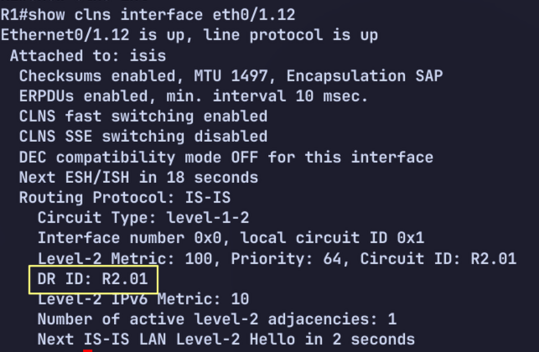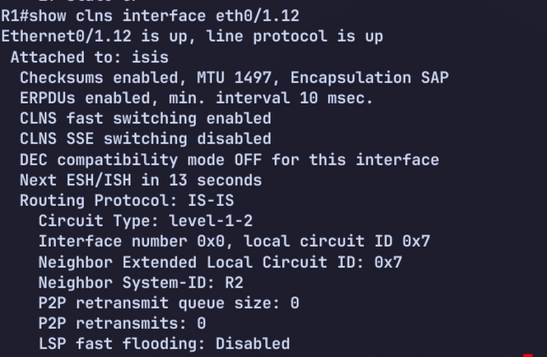

Verify holdtime. This is the Neighbor’s Holdtime, not local timer.

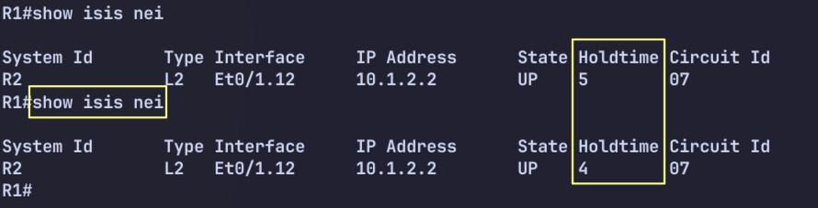

We can verify local timer on IOS-XR.
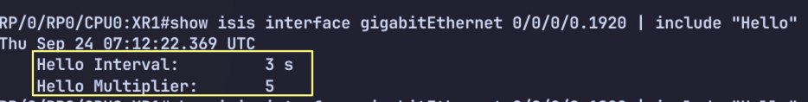

Mesh Groups

Load Config
# IOL
configure replace unix:labconfigs/isis.cfg force

# IOS-XR
configure
load config:labconfigs/isis.cfg
commit replace confirmed minutes 1
commit
Configure R2 so that LSPs received on eth0/1.12 are only forwarded out eth0/1.24. LSPs received on eth0/1.23 should only be flooded out eth0/1.24 as well.

Answer
# R2

interface Ethernet0/1.12
isis mesh-group 10

interface Ethernet0/1.23
isis mesh-group 10

Explanation
By default, an LSP received on any interface will be flooded out all other interfaces. This can be an inefficient use of bandwidth in large scale, highly meshed topologies. To better scale ISIS, we can configure interfaces into groups for flooding.
If an interface belongs to an ISIS mesh-group, any LSP received on that interface is only flooded out other interfaces that are not in the same mesh group.

LSP recv on .12
├──> .23 ❌ same mesh-group
└──> .24 ✅

LSP recv on .23
├──> .12 ❌ same mesh-group
└──> .24 ✅

Before Mesh Group
Use debug isis update-packet on R2, and Shutdown lo0 on R1 to force R1 to update its LSP.
ISIS-Upd: from SNPA aabb.cc00.0110 (Ethernet0/1.12)
Upd ISIS-Upd: LSP newer than database copy
Upd ISIS-Upd: TLV contents different, code 132
Upd ISIS-Upd: TID 0 leaf routes changed
Upd ISIS-Upd: Sending L2 LSP 0000.0000.0001.00-00, seq 6
Upd ISIS-Upd: ht 1199 on Ethernet0/1.24 via high priority queue
Upd ISIS-Upd: Sending L2 LSP 0000.0000.0001.00-00, seq 6
Upd ISIS-Upd: ht 1199 on Ethernet0/1.23 via high priority queue
Dec ISIS-Upd: Node cache: processing R1.00-00 Level 2
Dec ISIS-Upd: Node cache: lsp_zero found R1.00-00 Level 2
Dec ISIS-Upd: Node cache Parse lsp R1.00-00 Level 2
Dec ISIS-Upd: Node cache update: Node found: yes lsp R1.00-00 Level 2

After Mesh Group
LSP received on eth0/1.12 is flooded only to eth0/1.24.
ISIS-Upd: Rec L2 LSP 0000.0000.0001.00-00, seq 7, ht 1200,
ISIS-Upd: from SNPA aabb.cc00.0110 (Ethernet0/1.12)
Upd ISIS-Upd: LSP newer than database copy
Upd ISIS-Upd: TLV contents different, code 132
Upd ISIS-Upd: TID 0 leaf routes changed
Upd ISIS-Upd: Sending L2 LSP 0000.0000.0001.00-00, seq 7
Upd ISIS-Upd: ht 1199 on Ethernet0/1.24 via high priority queue
Dec ISIS-Upd: Node cache: processing R1.00-00 Level 2
Dec ISIS-Upd: Node cache: lsp_zero found R1.00-00 Level 2
Dec ISIS-Upd: Node cache Parse lsp R1.00-00 Level 2
Dec ISIS-Upd: Node cache update: Node found: yes lsp R1.00-00 Level 2

Prefix Summarization

Load Config
# IOL
configure replace unix:labconfigs/isis.inter.area.cfg force

# IOS-XR
configure
load config:labconfigs/isis.inter.area.cfg
commit replace confirmed minutes 1
commit

The topology has been changed so that there are three ISIS areas now.
- Configure R3 and R4 to summarize R1’s loopback as 1.1.1.0/24 into Level 2.
- Configure R4 to summarize R5’s loopback as 5.5.5.0/24 into Level 1. No other prefixes should be leaked into Level 1.
- Configure XR1 to summarize XR2’s loopback as 20.20.20.0/24 into Level 2.
- Configure XR2 to redistribute a new prefix, 20.20.200.20/32 into ISIS and summarize it as 20.20.200.0/24.

Answer

# R3 & R4
router isis
Summary-address 1.1.1.0 255.255.255.0 level-2

# R4

ip prefix-list L2_To_L1 seq 5 permit 5.5.5.5/32

route-map L2_To_L1 permit 0
match ip address prefix-list L2_To_L1

router isis
summary-address 5.5.5.0 255.255.255.0 level-1
redistribute isis ip level-2 into level-1 route-map L2_To_L1

# XR1
router isis 1
address-family ipv4 unicast
summary-prefix 20.20.20.0/24 level 2

# XR2
interface Loopback20
ipv4 address 20.20.200.20 255.255.255.255
!
route-policy Lo20
if destination in (20.20.200.20/32) then
pass
endif
end-policy
!
router isis 1
address-family ipv4 unicast
summary-prefix 20.20.200.0/24
redistribute connected level-1 route-policy Lo20
!
!
end

R1’s Loopback Before / After
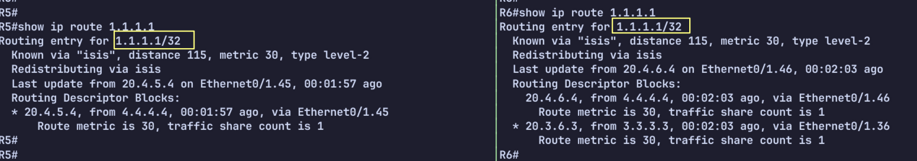
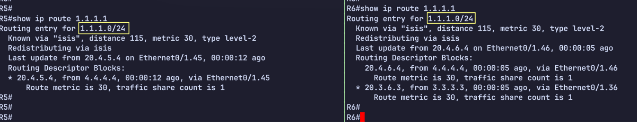
R5’s Loopback Before / After
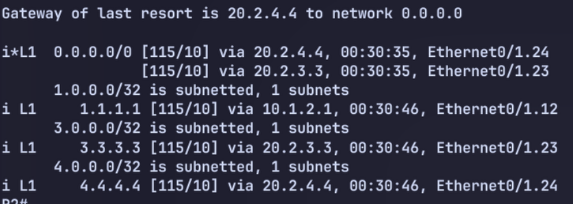
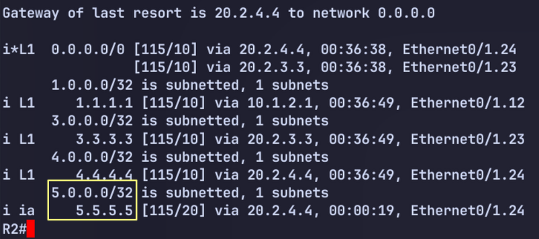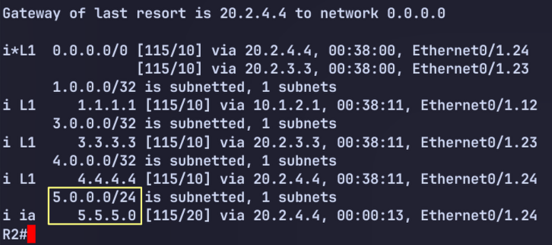

XR2’s Loopback
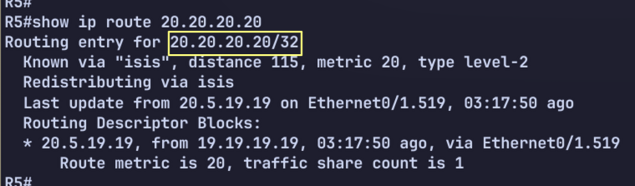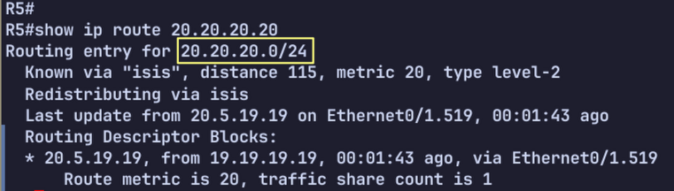

Explanation
When summarizing level 1 prefixes as they are advertised into level 2, you use the command summary-address <prefix> <mask> level-2. Optionally, you can leave the level-2 keyword out, as level 2 is the default.

When summarizing level 2 prefixes as they are advertised into level 1, you must first ensure that the routes are being leaked into level 1 in the first place. Then you use the summary command and specify level-1. The level is always the level you are advertising the prefixes into.

Default Route Preference

Load Config
# IOL
configure replace unix:labconfigs/isis.inter.area.cfg force

# IOS-XR
configure
load config:labconfigs/isis.inter.area.cfg
commit replace confirmed minutes 1
commit

- Configure area 49.1234 so that R2 prefers R3 for the default route, and only uses R4 upon loss of R3. Do not use metrics to achieve this.

Answer

router isis
default-information originate route-map SET_L1
route-map SET_L1 permit 10
set level level-1

Explanation
ISIS allows us to originate a default route just like OSPF. An L1 router will prefer an explicit 0/0 route that is advertised in the area over using the ATT bit.

Before Config
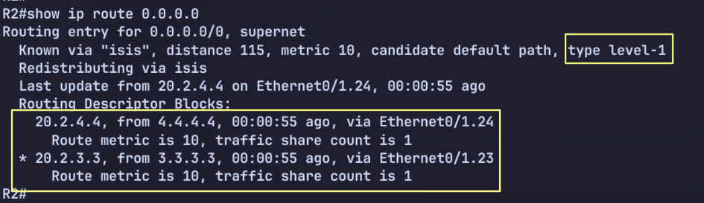

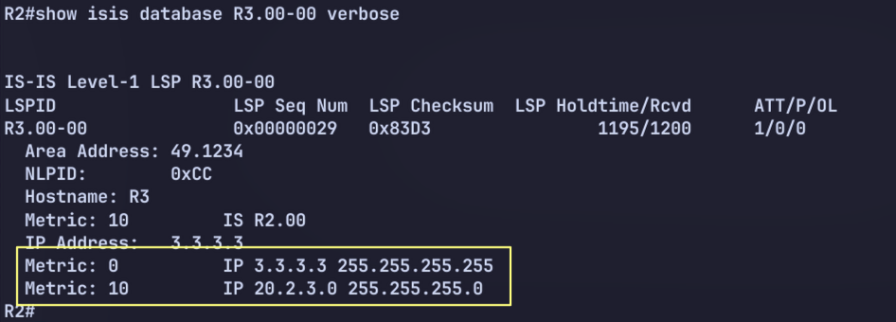

After Configuring default-information originate
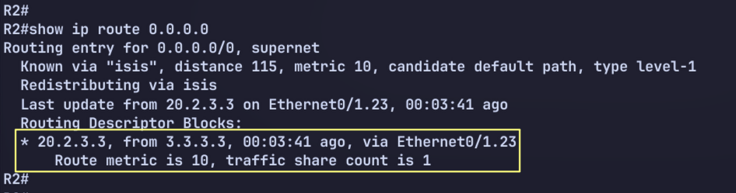
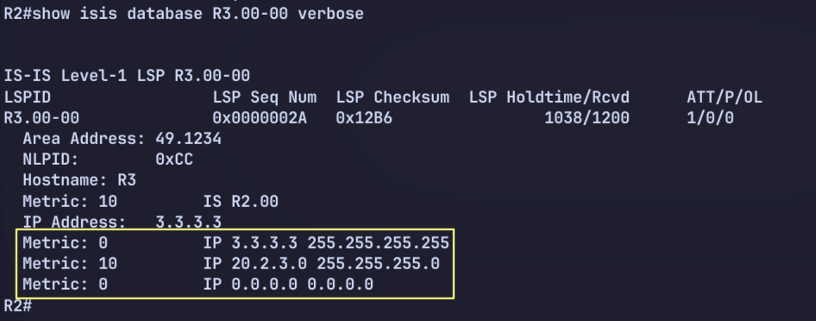

ISIS RIB still has both 0/0 routes generated from the ATT bit set on R3 and R4, but the explicit 0/0 is preferred and installed.
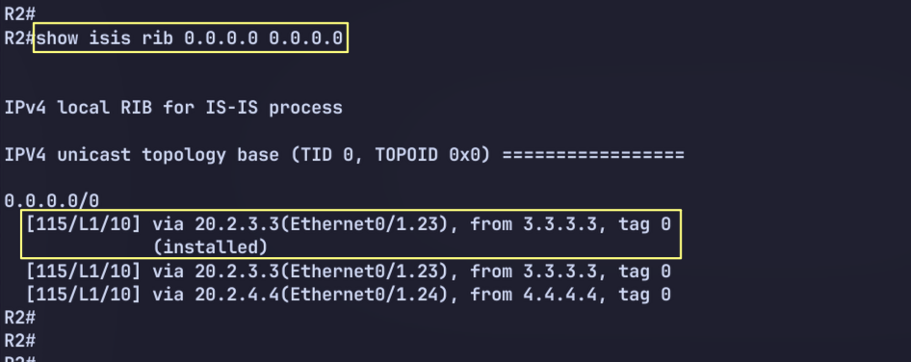

ISIS Timers

Load Config
# IOL
configure replace unix:labconfigs/isis.inter.area.cfg force

# IOS-XR
configure
load config:labconfigs/isis.inter.area.cfg
commit replace confirmed minutes 1
commit

Set R1 and XR2 to use the following ISIS timers:
- Local LSPs should have a max lifetime of 600 seconds. These LSPs should be refreshed every 300 seconds.
- Locally-generated LSPs should be throttled 500 msec after a change, 750 msec if occuring after an LSP was just generated previously, and a max backoff of 3 seconds.
- SPF calculation should be throttled 250 msec after receiving an update, 500 msec if an SPF run has just occured, and a max wait time of 3 seconds.
- Partial route calculation should use the same timers as SPF calculation.
- During flooding, interfaces should pace LSPs at 20 msec intervals
- During flooding, the router should allow for up to 3 seconds before retransmitting the same LSP. If LSPs do need to be retransmitted, these should be paced at 40 msec intervals.

Answer

# R1
router isis
max-lsp-lifetime 600
lsp-refresh-interval 300
spf-interval 3 250 500
prc-interval 3 250 500
lsp-gen-interval 3 500 750
!
int Eth0/1.12
isis lsp-interval 20
isis retransmit-interval 3
isis retransmit-throttle-interval 40

# XR2
router isis 1
max-lsp-lifetime 600
lsp-refresh-interval 300
lsp-gen-interval initial-wait 500 secondary-wait 750 maximum-weight 3000
!
address-family ipv4 unicast
spf-interval initial-wait 250 second-wait 500 maximum-wait 3000
!
int Gi0/0/0/0.1920
lsp-interval 20
retransmit-interval 3
retransmit-throttle-interval 40

Explanation

The max-lsp-lifetime command sets the lifetime on locally generated LSPs. By default this appears to be 1200 seconds. This defines how long an LSP is valid in the LSDB. A longer interval allows for less frequent refreshes, which saves some bandwidth in a large network.

Log Neighbor Changes

Load Config
# IOL
configure replace unix:labconfigs/isis.inter.area.cfg force

# IOS-XR
configure
load config:labconfigs/isis.inter.area.cfg
commit replace confirmed minutes 1
commit

Configure R1 so that when eth0/1.12 is manually shut down, the following log message appears:
%CLNS-5-ADJCHANGE: ISIS: Adjacency to R2 (Ethernet0/1.12) Down, interface deleted(non-iih)
Configure R2 so that when eth0/1.12 on R1 is shut down, no log message appears at all.

Answer
# R1
router isis
log-adjacency-changes all

# R2
router isis
no log-adjacency-changes

Explanation

By default, log-adjacency-changes is enabled. However, this only logs adjacency changes that are detected through the ISIS Hello. If the interface goes down, the adjacency is lost based on the interface, not the missing Hellos, so no log is generated. If we use the all keyword, it will log all adjacency changes, even those caused by non-Hello events.

Troubleshooting 1 – No routes

Load Config

# IOL
configure replace unix:labconfigs/isis.tshoot1.cfg

# IOS-XR
configure
load config:labconfigs/isis.tshoot1.cfg
commit replace confirmed minutes 1
commit

R1 and XR2 have no ISIS routes in the routing table. Fix the issue without disabling any features that have been enabled on any other routers. You may only configure two routers.

Answer

# R1
router isis
metric-style wide / transition

# XR2
router isis 1
address-family ipv4 unicast
metric-style wide / transition

Explanation
If we look at the topology on R1 and XR2, we can see that all routers have ** for the metric. This indicates a metric-style mismatch:

R1#show isis topology

IS-IS TID 0 paths to level-2 routers
System Id Metric Next-Hop Interface SNPA
R1 --
R2 **
R3 **
R4 **
R5 **
R6 **
XR1 **
XR2 **

R2#show isis topology

IS-IS TID 0 paths to level-2 routers
System Id Metric Next-Hop Interface SNPA
R1 **
R2 --
R3 10 R3 Et0/1.23 aabb.cc00.0310
R4 10 R4 Et0/1.24 aabb.cc00.0410
R5 20 R4 Et0/1.24 aabb.cc00.0410
R6 20 R3 Et0/1.23 aabb.cc00.0310
R4 Et0/1.24 aabb.cc00.0410
XR1 30 R3 Et0/1.23 aabb.cc00.0310
R4 Et0/1.24 aabb.cc00.0410
XR2 **

R1#show isis protocol | in metrics
Generate narrow metrics: level-1-2
Accept narrow metrics: level-1-2
Generate wide metrics: none
Accept wide metrics: none

R2#show isis protocol | in metrics
Generate narrow metrics: none
Accept narrow metrics: none
Generate wide metrics: level-1-2
Accept wide metrics: level-1-2

RP/0/RP0/CPU0:XR1#show isis protocol | in Metric
Tue Oct 20 04:10:27.157 UTC
Maximum Metric: not configured
Metric style (generate/accept): Wide/Wide
Metric: 10

RP/0/RP0/CPU0:XR2#show isis protocol | in Metric
Tue Oct 20 04:10:27.147 UTC
Maximum Metric: not configured
Metric style (generate/accept): Narrow/Narrow
Metric: 10

Troubleshooting 2 – Adjacency

Load Config
# R1, R2
configure replace unix:labconfigs/isis.tshoot2.cfg

Fix the broken adjacency between R1 and R2.

Answer

Cisco explains that in IPv6 single-topology IS-IS, routers must have the same set of address families on the same link, and IS-IS performs a consistency check on the IPv6 information within the hello packets. If one side runs IPv4+IPv6 while the other side only runs IPv4, the adjacency can be rejected or encounter issues.

R1 R2
E0/1.12 ─────────────────── E0/1.12

IPv4 IS-IS ✅ IPv4 IS-IS ✅
IPv6 IS-IS ✅ IPv6 IS-IS ❌
IPv6 link-local ✅? IPv6 link-local ❌

alternative option for transition
# R1

router isis
address-family ipv6
no adjacency-check

Explanation
There are several things wrong here. The following must match for an adjacency to come up:
- Common subnet for IPv4
- Protocols supported must match and multitopology mode must match
  - However, if one side uses ST and one uses MT transition, then both IPv4 and IPv6 will work
- Circuit types and router levels must match/be compatible
- Hello auth must match
- MTU must match
The following was broken in this situation:
- R2 has a misconfigured key-string
- R2 is in the wrong IPv4 subnet
- R1 does not use p2p as the circuit type
- R1 is level-1 only, while R2 is level-2 only
- R1 has a larger MTU on the interface. R2 won’t be able to accept fully padded Hellos from R1
- R1 is running IPv6 on the interface and R2 is not
  - IOS-XE uses single-topology by default, in which both IPv4 and IPv6 are required if one side has IPv6 enabled.
  - An alternative would be to enable wide metrics on both sides, and then use multi-topology on R1. This would allow the adjacency to come up without R2 supporing IPv6. This is because each protocol has its own topology now on R1.

Troubleshooting 3

Load Config
# R1..R6
configure replace unix:labconfigs/isis.tshoot3.cfg

All adjacency is up, but R3 to R6 can’t ping R1’s loopback using their own loopback as source.

Answer
# R1, R2
int eth0/1.12
no isis circuit-type

# R1
router isis
is-type level-1-2

Explanation
All routers are in the same area, but R1-R2 adjacency is L1 only. R1 only know R2, however R2 won’t send default route to R1 because it isn’t connected to other area.
R1#show clns
Global CLNS Information:
1 Interfaces Enabled for CLNS
Configuration Timer: 60, Default Holding Timer: 300, Packet Lifetime 64
ERPDU's requested on locally generated packets
Running IS-IS in IP-only mode (CLNS forwarding not allowed)
NET: 49.0001.0000.0000.0001.00

R1#show isis database

IS-IS Level-1 Link State Database:
LSPID LSP Seq Num LSP Checksum LSP Holdtime/Rcvd ATT/P/OL
R1.00-00 * 0x0000001A 0x2E1F 1197/* 0/0/0
R2.00-00 0x00000010 0x8795 1196/1200 0/0/0

IPv6 Single Topology

Load Config
# IOS-XE
config replace unix:labconfigs/isis.ipv6.init.cfg

# IOS-XR
configure
load config:labconfigs/isis.ipv6.init.cfg
commit replace
y
All routers have IPv6 link-local addresses enabled on their interfaces, and a loopback IPv6 address of 2001:db8::<router num>/128.
- Without enabling wide metrics, configure IPv6 reachability between all routers on their loopbacks.

Answer
IOS-XE’s default IPv6 mode is single topology. In single topology, IPv6 “uses” the IPv4 topology. The IPv6 prefixes ride on top of the IPv4 topology and its adjacencies. IPv6 prefixes are simply advertised with TLV 236. This is used whether or not wide metrics are used. (Either can be used with single topology).

The link-local address, used for the nexthop by the neighbor for IPv6 routes, is advertised in the Hello in the IPv6 interface address TLV (232).
On IOS-XR, we must enable single-topology under the AFI. By default IOS-XR uses multi topology, in which IPv4 and IPv6 each have a separate topology, and IPv6 is not required to be enabled on every interface.
In summary:
- IPv6 can be used with either single topology or multi topology
  - In single topology, IPv6 uses the IPv4 topology. IPv6 prefixes are advertised in a separate IPv6 reachability TLV (236)
- Single topology is the default mode on IOS-XE
- Multi topology is the default mode on IOS-XR
- In single topology, every link must have both IPv4 and IPv6. If any router does not have IPv6 enabled, both IPv4 and IPv6 reachability is broken.
  - This is because the adjacency requires all protocols be supported between both neighbors
  - The exception is that you can use single topology and only IPv6. No IPv4 anywhere in the topology. In this case, the protocols supported TLV lists only IPv6 by itself.
- Single topology can use either narrow or wide metrics. Multi topology requires wide metrics.

IPv6 Single Topology Challenge

Load

# IOS-XE
config replace unix:labconfigs/isis.st.challenge.init.cfg

# IOS-XR
configure
load config:labconfigs/isis.st.challenge.init.cfg
commit replace
y
- R1 and XR2 have enabled IPv6 support using ST mode.
- R2 and XR1 have not yet implemented IPv6.
- The operator has found that the adjacencies between R1-R2 and XR1-XR2 are now broken.
- Find a way to fix this without enabling IPv6 support on R2 or XR1, and without disabling IPv6 support on R1 or XR2.

Answer

# R1
router isis
address-family ipv6
no adjacency-check

# XR2
router isis 1
address-family ipv6 unicast
adjacency-check disable
!
!

Explanation
A router that enables IPv6 on an interface using ST mode requires that the neighbor supports both IPv4 and IPv6 in the protocols supported TLV. If the neighbor only supports IPv4, the router will not bring the adjacency up.

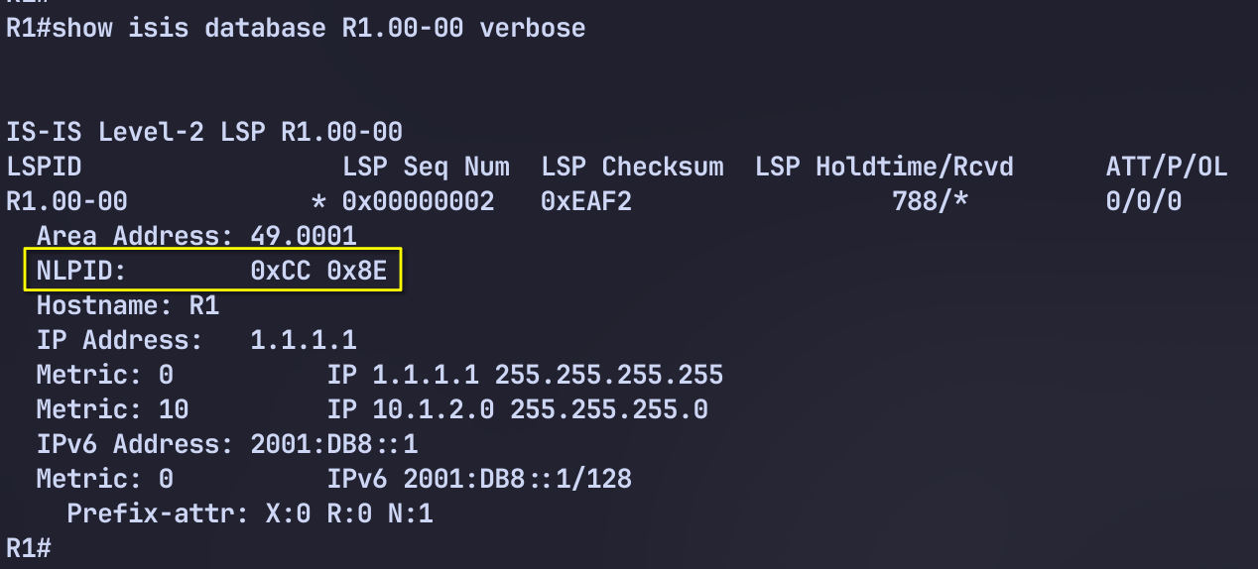
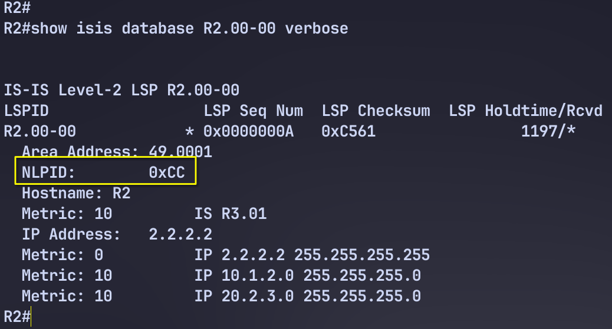
To get around this, we can configure the router to disable this adjacency check.

IPv6 Multitopology

Load Config
# IOS-XE
config replace unix:labconfigs/isis.ipv6.init.cfg

# IOS-XR
configure
load config:labconfigs/isis.ipv6.init.cfg
commit replace
y

All routers have IPv6 link-local addresses enabled on their interfaces, and a loopback IPv6 address of 2001:db8::<router num>/128.
Configure IPv6 reachability using multi topology.

Answer
# IOS-XE
router isis
metric-style wide
address-family ipv6
multi-topology
int xxx
ipv6 router isis

# IOS-XR
router isis 1
address-family ipv4 unicast
metric-style wide
!
interface Loopback0
address-family ipv6 unicast
!
!
interface GigabitEthernet0/0/0/0.1920
address-family ipv6 unicast

Explanation

show isis ipv6 topology
show isis topology

# ios-xr
show isis database verbose | utility egrep "NLPID|00-00"

# ios-xe
show isis database verbose | in NLPID|00-00

IPv6 Single to Multitopology

Load Config
# IOS-XE
config replace unix:labconfigs/isis.ipv6.st.cfg

# IOS-XR
configure
load config:labconfigs/isis.ipv6.st.cfg
commit replace
y

All routers have IPv6 link-local addresses enabled on their interfaces, and a loopback IPv6 address of 2001:db8::<router num>/128.
Single-topology IPv6 has already been setup. Migrate to Multi-topology for IPv6 without breaking IPv4 or IPv6 reachability.

Explanation
In phase one, we first enable wide-metrics everywhere. This is because MT on IOS-XE requires wide metrics. We enable it using the transition method, in which both narrow and wide metrics are generated and received.

# IOS-XE
router isis
Metric-style transition

# IOS-XR
Router isis 1
address-family ipv4
Metric-style transition

Now we can remove the transition style and use only wide-metrics.

# IOS-XE
router isis
metric-stydde

# IOS-XR
Router isis 1
address-family ipv4
Metric-style wide

In phase two we enable multi-topology on all routers but with the transition keyword. This forces the router to continue generating the IPv6 reachability TLV which is used in single-topology.

# IOS-XE
router isis
add ipv6
multi-topology transition

# IOS-XR
router isis 1
address-family ipv6
no single-topology !!! no transition mode on IOS-XR

Note that we lost reachability on XRv neighbors with this step because we had to enable multi-topology only. There is no “transition” mode in which XRv continues generating normal ST IPv6 prefix reachability TLVs. Specifically, when making the change first on routers R1-R6, and then on XR1, XR1 loses its reachability to XR2 prefixes. But it still has reachability to all routers R1-R6. We then turn ST off on XR2, and reachability is restored.
Now that all routers are running MT, we can turn the transition mode off.

# IOS-XE
router isis
add ipv6
multi-topology

Summary
The transition keyword for multi-topology is only available on IOS-XE. When you use this keyword, the router continues generating IPv6 reachability TLVs (236) in addition to the MT IPv6 reachable prefixes TLV (237). This allows other routers that are still running in ST mode to continue to work.

Wide Metrics

Load Metric

# CSR
configure replace tftp://10.0.0.2/configs/isis.inter.area.cfg

# IOS-XR
configure
load config:labconfigs/isis.inter.area.cfg
commit replace confirmed minutes 1
commit

Narrow metric TLVs is 6 bits, so the max value is 63.

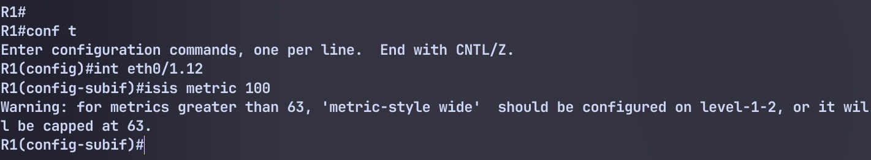
Redistribute a route on R1 into level 1 and notice the behavior.

# R1
int lo100
ip add 100.1.1.1 255.255.255.255
!
route-map LO100
match int lo100
!
router isis
redistribute connect route-map LO100 level-1

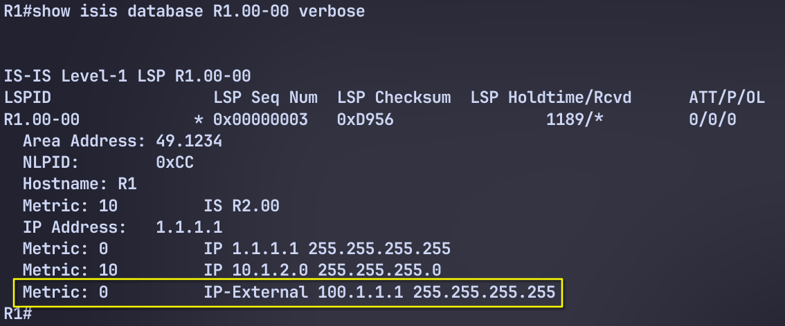

# R1
#R1
router isis
metric-style transition

Route Filtering
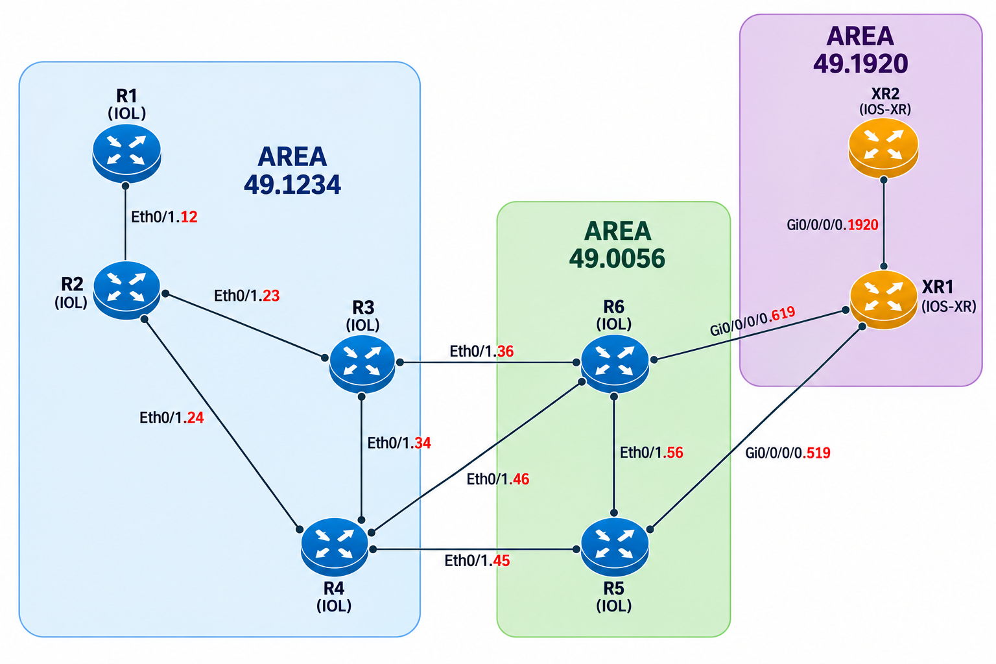

Load Config
# IOS-XE
config replace unix:labconfigs/isis.inter.area.cfg

# IOS-XR
configure
load config:labconfigs/isis.inter.area.cfg
commit replace
y
On XR2, configure Lo20 with IP 200.20.20.20/32. Redistribute this into ISIS with tag=20.
On R3 and R4, filter routes with tag=20 from being redistributed into L1. Allow all other L2 routes to be redistributed.

Answer
First we must switch to wide-style metrics to use tags. The narrow metric external IP reachability TLV does not have a tag field.

Redistribute with correct tag
# XR2

int Lo20
ip add 200.20.20.20/32
!
route-policy lo20
if destination in ( 200.20.20.20/32 ) then
set tag 20
endif
end-policy
!
router isis 1
address-family ipv4 unicast
redistribute connected level-1 route-policy lo20

On R3 and R4 we redistribute all L2 routes into L1 except for tag 20:

# R3, R4
route-map nolo20 deny 5
match tag 20
route-map nolo20 permit 10
!
router isis
redistribute isis ip level-2 into level-1 route-map nolo20

Backdoor Link
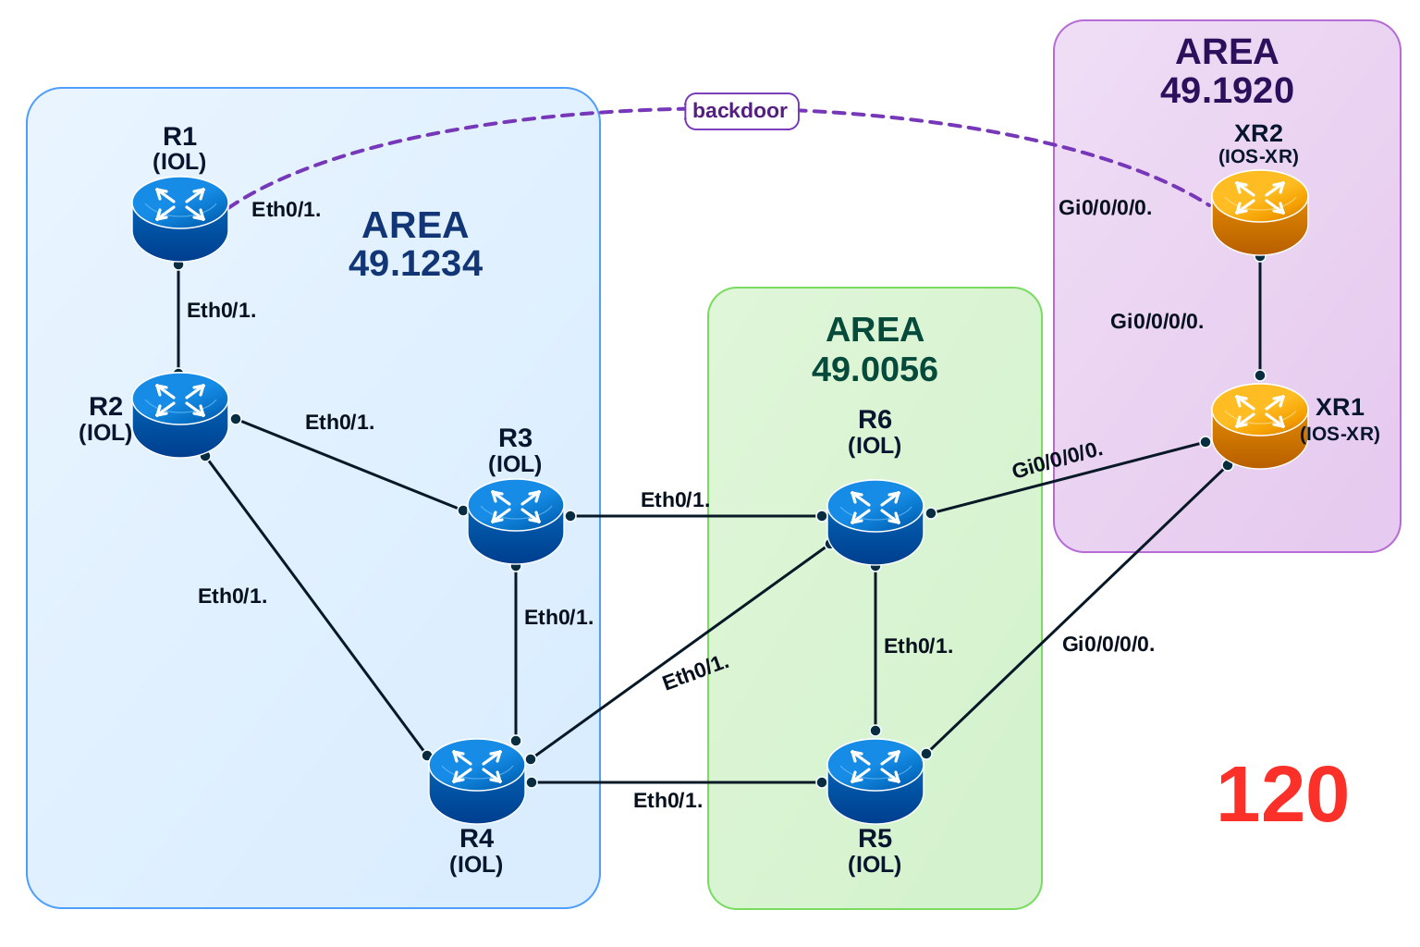
Figure 0-2 ISIS Backdoor

Load Config
# IOS-XE
config replace unix:labconfigs/isis.inter.area.cfg

# IOS-XR
configure
load config:labconfigs/isis.inter.area.cfg
commit replace
y
- Configure an additional link between R1 and XR2, using vlan 120 with subnet 20.1.20.0/24.
- Configure this link so that area 49.1234 and 49.1920 can reach each other directly without traversing the L2 backbone.
- Do not let traffic destined for any other areas run over this link.

Answer
# R1
router isis
is-type level-1-2 backdoor

# XR2
router isis 1
address-family ipv4 unicast
attached-bit send never-set

Explanation
The backdoor feature configures a L1/L2 router to do two things:
- Not set the ATT bit in L1 LSPs
- Continue installing a default route via other L1 routers that have the ATT bit set
On IOS-XE this is configured with is-type level-1-2 backdoor. On IOS-XR this is configured using attached-bit send never-set.

R1#show isis database

IS-IS Level-1 Link State Database:
LSPID LSP Seq Num LSP Checksum LSP Holdtime/Rcvd ATT/P/OL
R1.00-00 * 0x00000004 0xE20B 1035/* 0/0/0
R2.00-00 0x00000002 0xAF5C 369/1200 0/0/0
R3.00-00 0x00000004 0xCDAE 1158/1198 1/0/0
R4.00-00 0x00000004 0x3839 1181/1198 1/0/0
IS-IS Level-2 Link State Database:
LSPID LSP Seq Num LSP Checksum LSP Holdtime/Rcvd ATT/P/OL
R1.00-00 * 0x00000004 0x094C 1077/* 0/0/0
XR2.00-00 0x00000003 0xCD85 1084/1191 0/0/0
XR2.05-00 0x00000001 0xFC9C 1084/1191 0/0/0

R1#show ip route isis | beg Gate
Gateway of last resort is 10.1.2.2 to network 0.0.0.0

i*L1 0.0.0.0/0 [115/20] via 10.1.2.2, 00:00:13, Ethernet0/1.12
2.0.0.0/32 is subnetted, 1 subnets
i L1 2.2.2.2 [115/10] via 10.1.2.2, 00:10:15, Ethernet0/1.12
3.0.0.0/32 is subnetted, 1 subnets
i L1 3.3.3.3 [115/20] via 10.1.2.2, 00:10:15, Ethernet0/1.12
4.0.0.0/32 is subnetted, 1 subnets
i L1 4.4.4.4 [115/20] via 10.1.2.2, 00:10:15, Ethernet0/1.12
10.0.0.0/8 is variably subnetted, 5 subnets, 2 masks
i L2 10.19.20.0/24 [115/20] via 10.1.20.20, 00:09:02, Ethernet0/1.120
19.0.0.0/32 is subnetted, 1 subnets
i L2 19.19.19.19 [115/20] via 10.1.20.20, 00:09:02, Ethernet0/1.120
20.0.0.0/8 is variably subnetted, 3 subnets, 2 masks
i L1 20.2.3.0/24 [115/20] via 10.1.2.2, 00:10:15, Ethernet0/1.12
i L1 20.2.4.0/24 [115/20] via 10.1.2.2, 00:10:15, Ethernet0/1.12
i L2 20.20.20.20/32 [115/10] via 10.1.20.20, 00:09:02, Ethernet0/1.120

RP/0/RP0/CPU0:XR2#show isis database
Tue Oct 20 04:27:47.158 UTC

IS-IS 1 (Level-1) Link State Database
LSPID LSP Seq Num LSP Checksum LSP Holdtime/Rcvd ATT/P/OL
XR1.00-00 0x00000004 0xe811 1102 /1200 1/0/0
XR2.00-00 * 0x00000005 0xa69a 1079 /* 0/0/0

Total Level-1 LSP count: 2 Local Level-1 LSP count: 1

IS-IS 1 (Level-2) Link State Database
LSPID LSP Seq Num LSP Checksum LSP Holdtime/Rcvd ATT/P/OL
R1.00-00 0x00000004 0x094c 989 /1200 0/0/0
XR2.00-00 * 0x00000003 0xcd85 989 /* 0/0/0
XR2.05-00 0x00000001 0xfc9c 989 /* 0/0/0

RP/0/RP0/CPU0:XR2#show route isis
Tue Oct 20 04:32:15.705 UTC

i*L1 0.0.0.0/0 [115/10] via 10.19.20.19, 00:06:28, GigabitEthernet0/0/0/0.1920
i L2 1.1.1.1/32 [115/10] via 10.1.20.1, 00:07:58, GigabitEthernet0/0/0/0.120
i L2 2.2.2.2/32 [115/20] via 10.1.20.1, 00:07:58, GigabitEthernet0/0/0/0.120
i L2 3.3.3.3/32 [115/30] via 10.1.20.1, 00:07:58, GigabitEthernet0/0/0/0.120
i L2 4.4.4.4/32 [115/30] via 10.1.20.1, 00:07:58, GigabitEthernet0/0/0/0.120
i L2 10.1.2.0/24 [115/20] via 10.1.20.1, 00:07:58, GigabitEthernet0/0/0/0.120
i L1 19.19.19.19/32 [115/10] via 10.19.20.19, 00:18:39, GigabitEthernet0/0/0/0.1920
i L2 20.2.3.0/24 [115/30] via 10.1.20.1, 00:07:58, GigabitEthernet0/0/0/0.120
i L2 20.2.4.0/24 [115/30] via 10.1.20.1, 00:07:58, GigabitEthernet0/0/0/0.120

Non-Optimal Intra-Area Routing

Load Config
# IOS-XE
config replace unix:labconfigs/isis.non-optimal.intra-area.cfg

# IOS-XR
configure
load config:labconfigs/isis.non-optimal.intra-area.cfg
commit replace
y

R1 is now connected to both R3 and R4.

Shutdown the R1-R3 link and do a traceroute to 1.1.1.1 from R3. Traffic is from R3 to R1 is flowing to R2-R4-R1 instead of R4-R1. Explain the issue and find a way to fix it so that traffic takes the path R4-R1.

Answer
# R3, R4
interface eth0/1.34
isis circuit-type level-1-2

Explanation

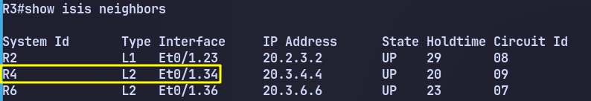

The reason for this non-optimal routing is because the R3-R4 link is level-2-only.
Routers prefer intra-area routes over inter-area routes. This means an L1 route is preferred over an L2 route.
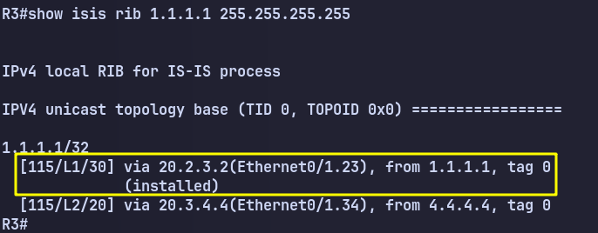
Even though R3 and R4 are in the same area, they only have an L2 adjacency. The route to 1.1.1.1 via R4 is an L2 route, which although a shorter metric, loses against the higher metric L1 route via R2.

Multi Area
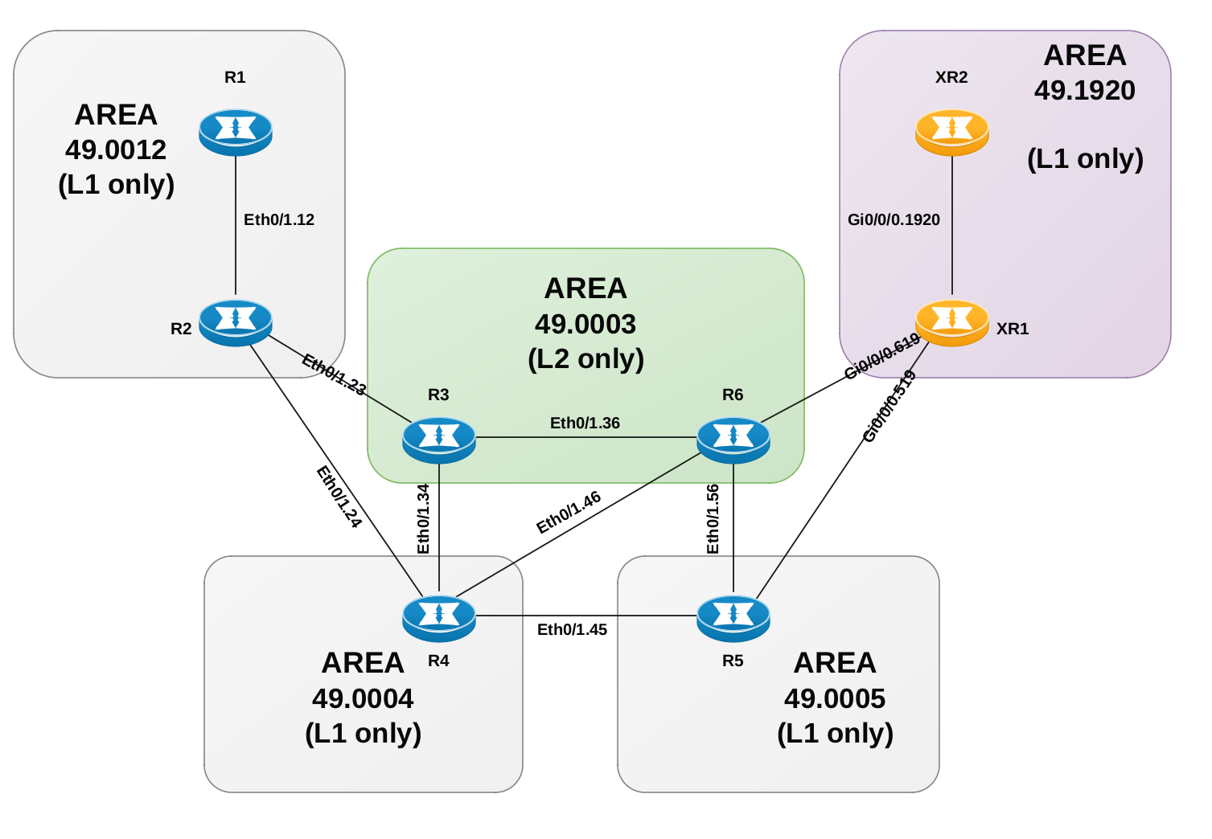

Load Config
# IOS-XE
config replace unix:labconfigs/isis.multi.area.cfg

# IOS-XR
configure
load config:labconfigs/isis.multi.area.cfg
commit replace
y

All routers are pre-configured in their respective ISIS areas. All links are L1-only except for Eth0/1.36 on R3 and R6.
Without changing the L1-only areas or changing the circuit types, fix the design so that inter-area routing is achieved.

Answer

# R3
router isis
net 49.0012.0000.0000.0003.00
net 49.0004.0000.0000.0003.00

# R6
router isis
net 49.1920.0000.0000.0006.00
net 49.0005.0000.0000.0006.00

Explanation
The solution to this involves setting multiple NET addresses on R3 and R6. This allows these routers to participate in multiple ISIS areas.
The problem is that ISIS by default allows up to 3 areas on a single router. This is a negotiated value in the ISIS hello. R6 will need to participate in 4 areas. So first, we would change the maximum areas supported on all routers to 4.

Unfortunately, IOS-XR does not support a different max-area-address number besides 0 or 3. (0 implies a value of 3). So we cannot use this solution.
Instead we will have to leave the default at 3 max addresses and not create an adjacency between R4-R6. We will configure R3 and R6 with additional NET addresses.

Authentication 1
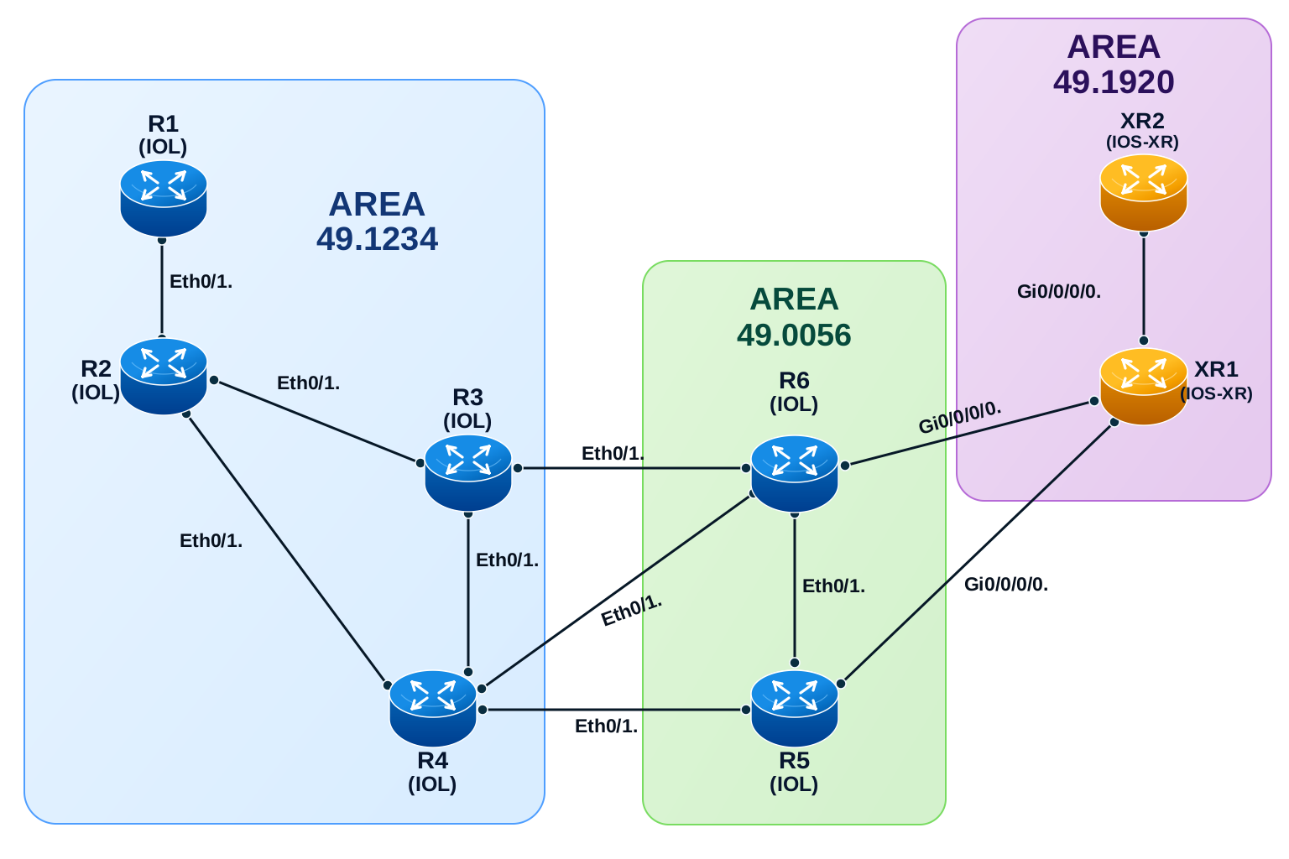
Figure 0-3 ISIS InterArea

Load Config
# IOS-XE
config replace unix:labconfigs/isis.inter.area.cfg

# IOS-XR
configure
load config:labconfigs/isis.inter.area.cfg
commit replace
y

Configure area 49.1234 as follows:
- R1-R2 should use HELLO123 as the hello password using the legacy syntax.
- R2-R3-R4 should all use HELLO234 as the password using MD5.
- The area should authenticate L1 LSPs and SNPs using “AREA1234” in clear text, but they should all be accepted if they do not contain authentication. Use the legacy syntax for this.

Answer
# R1
int Eth0/1.12
isis password HELLO123
# R2
int Eth0/1.12
isis password HELLO123
int Eth0/1.23
isis authentication mode md5
isis authentication key-chain ISIS_HELLO
int Eth0/1.24
isis authentication mode md5
isis authentication key-chain ISIS_HELLO
!
key chain ISIS_HELLO
key 1
key-string HELLO234

# R3
int Eth0/1.23
isis authentication mode md5
isis authentication key-chain ISIS_HELLO
int Eth0/1.34
isis authentication mode md5
isis authentication key-chain ISIS_HELLO
!
key chain ISIS_HELLO
key 1
key-string HELLO234
!
# R4
int Eth0/1.24
isis authentication mode md5
isis authentication key-chain ISIS_HELLO
int Eth0/1.34
isis authentication mode md5
isis authentication key-chain ISIS_HELLO
!
key chain ISIS_HELLO
key 1
key-string HELLO234
!

# R1, R2, R3, R4

router isis
area-password AREA1234 authenticate snp send-only

# R1
int eth1.12
isis password HELLO123

debug isis authentication information
ISIS-AuthInfo: Insert auth for Hello
ISIS-AuthInfo: Check authentication for Hello packet
ISIS-AuthInfo: No authentication TLV found in received packet
ISIS-AuthInfo: Insert auth for Hello
ISIS-AuthInfo: Check authentication for Hello packet
ISIS-AuthInfo: No authentication TLV found in received packet
ISIS-AuthInfo: Insert auth for Hello
ISIS-AuthInfo: Check authentication for Hello packet
ISIS-AuthInfo: No authentication TLV found in received packet
ISIS-AuthInfo: Insert auth for Hello
ISIS-AuthInfo: Check authentication for Hello packet
ISIS-AuthInfo: No authentication TLV found in received packet
%CLNS-4-AUTH_FAIL: ISIS: Serial IIH authentication failed
ISIS-AuthInfo: Insert auth for Hello
ISIS-AuthInfo: Check authentication for Hello packet
ISIS-AuthInfo: Packet has authentication type 1
ISIS-AuthInfo: Insert auth for Hello
ISIS-AuthInfo: Check authentication for Hello packet
ISIS-AuthInfo: Packet has authentication type 1
%CLNS-5-ADJCHANGE: ISIS: Adjacency to R2 (Ethernet0/1.12) Up, new adjacency

router isis
area-password AREA1234 authenticate snp send-only

ISIS-AuthInfo: Packet has authentication type 1
ISIS-AuthInfo: Insert auth for Hello
ISIS-AuthInfo: Insert auth for SNP or LSP
ISIS-AuthInfo: Check authentication for Hello packet
ISIS-AuthInfo: Packet has authentication type 1
ISIS-AuthInfo: Insert auth for Hello
ISIS-AuthInfo: Insert auth for SNP or LSP
ISIS-AuthInfo: Check authentication for Hello packet
ISIS-AuthInfo: Packet has authentication type 1

Authentication 2
Figure 0-3 ISIS InterArea

Load Config
# IOS-XE
config replace unix:labconfigs/isis.inter.area.cfg

# IOS-XR
configure
load config:labconfigs/isis.inter.area.cfg
commit replace
y

Configure area 49.0056 as follows:
- R5-R6 should use HELLO56 as the hello password in plain text using the new syntax. Allow received Hellos to not contain authentication, or to contain wrong authentication.
- The area should authenticate L1 LSPs and SNPs using “AREA56” in clear text. LSPs and SNPs should be accepted without authentication. Use the new syntax for this.

Answer
# R5, R6
key chain ISIS_HELLO
key 1
key-string HELLO56
!

int Eth0/1.56
isis authentication mode text
isis authentication key-chain ISIS_HELLO
isis authentication send-only

key chain ISIS_AREA
key 1
key-string AREA56

router isis
authentication mode text level-1
authentication send-only level-1
authentication key-chain ISIS_AREA level-1

Authentication 3

Load Config
# IOS-XE
config replace unix:labconfigs/isis.inter.area.cfg

# IOS-XR
configure
load config:labconfigs/isis.inter.area.cfg
commit replace
y

Configure area 49.1920 as follows:
- XR1-XR2 should use HELLO1920 as the hello password using MD5.
- The area should authenticate L1 LSPs and SNPs using “AREA1920” with MD5.

Answer
# XR1, XR2
router isis 1
lsp-password hmac-md5 AREA1920 level 1
!
int gi0/0/0/0.1920
hello-password hmac-md5 HELLO1920

Conditional ATT Bit

Load Config
# IOS-XE
config replace unix:labconfigs/isis.inter.area.cfg

# IOS-XR
configure
load config:labconfigs/isis.inter.area.cfg
commit replace
y
Configure R4 so that it only sets the attached bit for area 49.1234 when the prefix 200.200.200.200/32 is present in the routing table.

Answer
# R4

ip prefix-list lo200 seq 5 permit 200.200.200.200/32
route-map lo200 permit 10
match ip address prefix-list lo200

router isis
set-attached-bit route-map lo200

Troubleshoot iBGP
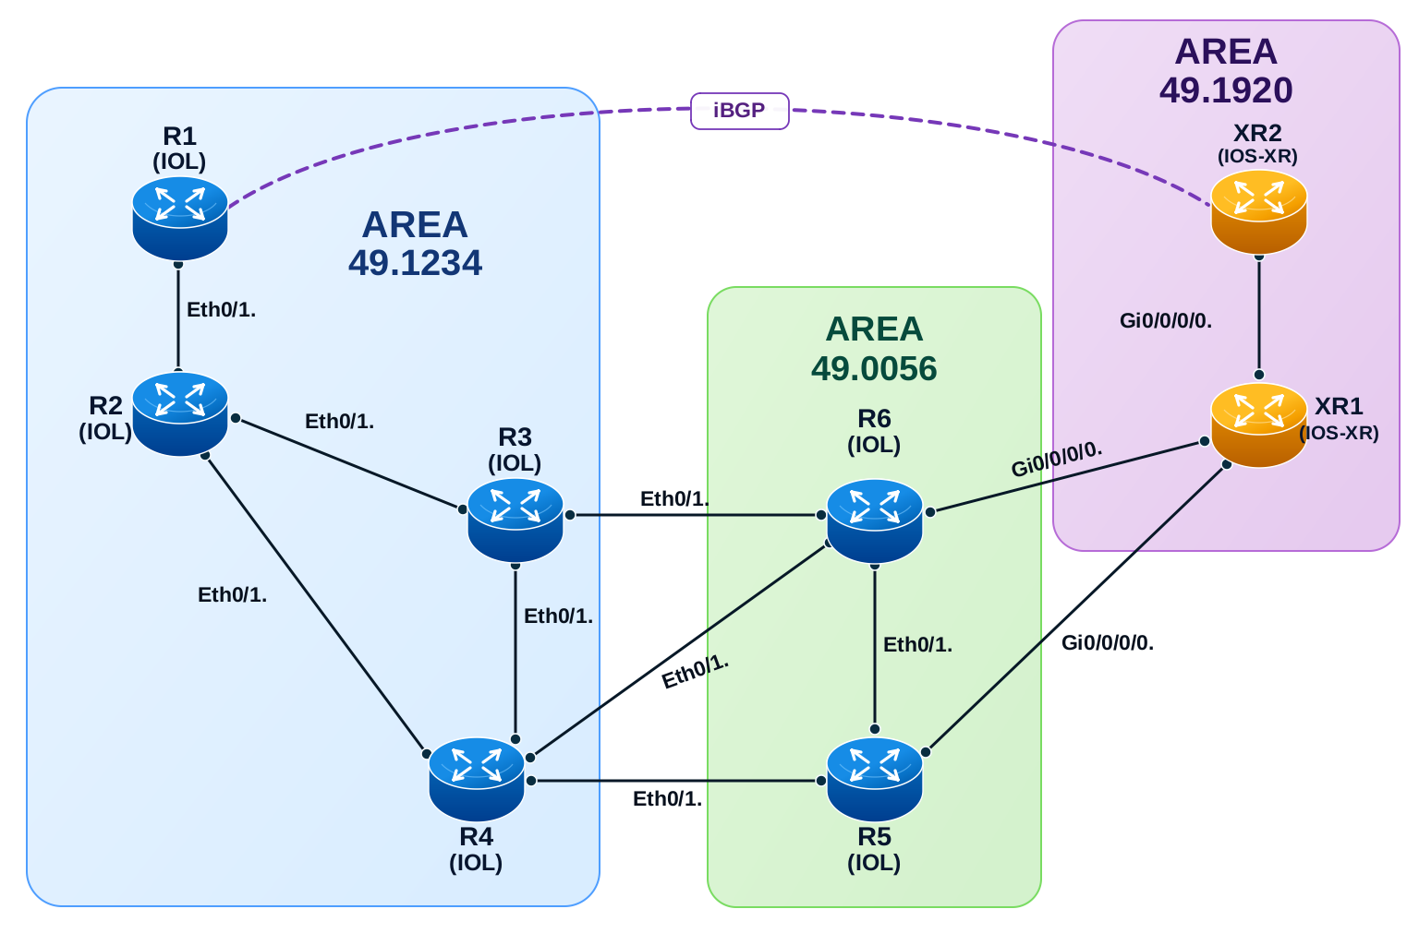

Load Config
# IOS-XE
config replace unix:labconfigs/isis.ibgp.tshoot.cfg force

# IOS-XR
configure
load config:labconfigs/isis.ibgp.tshoot.cfg
commit replace
An iBGP session is configured between R1 and XR2. R1 is advertising a prefix (100.100.100.100/32). LDP autoconfig has been added so that traffic can be tunneled between R1 and XR2.

Answer
# R3, R4
router isis
redistribute isis ip level-2 into level-1 route-map lo20

route-map lo20 permit 10
match ip address prefix-list lo20
ip prefix-list lo20 seq 5 permit 20.20.20.20/32

# XR1
route-policy L2_TO_L1
if destination in ( 1.1.1.1/32 ) then pass endif
end-policy
!
router isis 1
add ipv4 uni
propagate level 2 into level 1 route-policy L2_TO_L1

Explanation
IOS-XE and IOS-XR cannot use the 0/0 route to establish a BGP session with a peer.
R1#ping 20.20.20.20 source 1.1.1.1
Type escape sequence to abort.
Sending 5, 100-byte ICMP Echos to 20.20.20.20, timeout is 2 seconds:
Packet sent with a source address of 1.1.1.1
!!!!!

R1#show ip route 20.20.20.20
% Subnet not in table

R1#show bgp ipv4 unicast neighbors 20.20.20.20 | in route
BGP version 4, remote router ID 0.0.0.0
Address tracking is enabled, the RIB does have a route to 20.20.20.20

RP/0/RP0/CPU0:XR2#show bgp ipv4 unicast neighbors 1.1.1.1 | in route
Sat Oct 24 20:44:05.058 UTC
Remote router ID 0.0.0.0
BGP state = Idle (No route to multi-hop neighbor)
Advertise routes with local-label via Unicast SAFI

R1#debug ip bgp
BGP debugging is on for address family: IPv4 Unicast
R1#
BGP: 20.20.20.20 Active open failed - no route to peer, open active delayed 11264ms (35000ms max, 60% jitter)

The bgp peer comes up after R3 and R4 leaks 20.20.20.20/32 into level-1. But On IOS-XR, a nexthop cannot be resolved through the 0/0 route.
RP/0/RP0/CPU0:XR2#
RP/0/RP0/CPU0:XR2#show bgp ipv4 unicast 100.100.100.100/32
Sat Oct 24 20:56:17.589 UTC
BGP routing table entry for 100.100.100.100/32
Versions:
Process bRIB/RIB SendTblVer
Speaker 0 0
Last Modified: Oct 24 20:49:08.474 for 00:07:09
Paths: (1 available, no best path)
Not advertised to any peer
Path #1: Received by speaker 0
Not advertised to any peer
Local
1.1.1.1 (inaccessible) from 1.1.1.1 (100.100.100.100)
Origin IGP, metric 0, localpref 100, valid, internal
Received Path ID 0, Local Path ID 0, version 0

This is not the case with IOS-XE. Prove this with injecting routes on XR2, leak 1.1.1.1/32 from XR1, and stop leaking 20.20.20.20/32 on R3 and R4.

Troubleshoot TE Tunnel
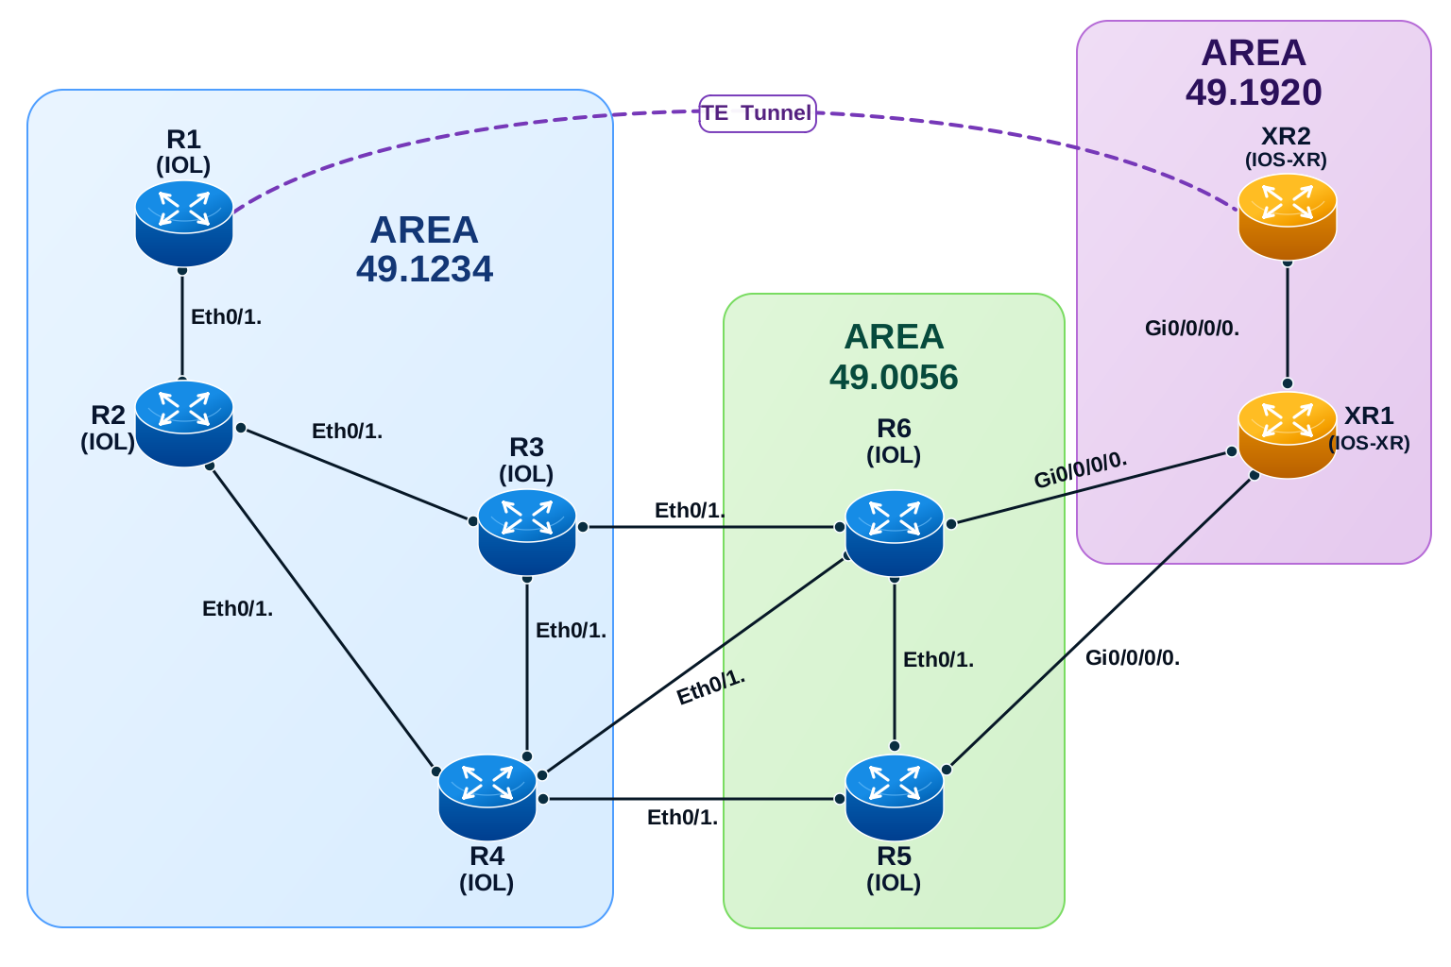

Load Config
# IOS-XE
config replace unix:labconfigs/isis.with.te.tshoot.init.cfg force

# IOS-XR
configure
load config:labconfigs/isis.with.te.tshoot.init.cfg
commit replace
A TE tunnel is setup on R1 with destination XR2. The tunnel is not coming up. Without making any changes to any other router besides R1, bring the tunnel up.
Do the same for the TE tunnel on XR2 with destination R1.

Answer
# R1
mpls traffic-eng path-selection overload allow middle

# XR2
configure
load config:labconfigs/isis.with.te.tshoot.init.cfg
commit replace

Explanation
R2 has the overload bit set.
R1#show mpls traffic-eng tunnels

P2P TUNNELS/LSPs:

Name: R1_t0 (Tunnel0) Destination: 20.20.20.20
Status:
Admin: up Oper: down Path: not valid Signalling: Down
path option 1, type dynamic

Config Parameters:
Bandwidth: 0 kbps (Global) Priority: 7 7 Affinity: 0x0/0xFFFF
Metric Type: TE (default)
Path-selection Tiebreaker:
Global: not set Tunnel Specific: not set Effective: min-fill (default)
Hop Limit: disabled
Cost Limit: disabled
Path-invalidation timeout: 10000 msec (default), Action: Tear
AutoRoute: disabled LockDown: disabled Loadshare: 0 [0] bw-based
auto-bw: disabled
Fault-OAM: disabled, Wrap-Protection: disabled, Wrap-Capable: No

History:
Tunnel:
Time since created: 6 minutes, 49 seconds
Time since path change: 19 seconds
Number of LSP IDs (Tun_Instances) used: 21
Prior LSP: [ID: 19]
ID: path option 1 [21]
Removal Trigger: path verification failed
Last Error: CTRL:: No path to destination, 0000.0000.0020.00 (no path)

P2MP TUNNELS:

P2MP SUB-LSPS:

R1#show mpls traffic-eng topology brief
My_System_id: 0000.0000.0001.00 (isis level-2)

Signalling error holddown: 10 sec Global Link Generation 19

IGP Id: 0000.0000.0001.00, MPLS TE Id:1.1.1.1 Router Node (isis level-2)
link[0]: Broadcast, DR: 0000.0000.0002.01, nbr_node_id:2, gen:12
frag_id: 0, Intf Address: 10.1.2.1
TE metric: 10, IGP metric: 10, attribute flags: 0x0
SRLGs: None

IGP Id: 0000.0000.0002.00, MPLS TE Id:2.2.2.2 Router Node (NO SPF) (isis level-2)
link[0]: Broadcast, DR: 0000.0000.0003.01, nbr_node_id:4, gen:13
frag_id: 0, Intf Address: 20.2.3.2
TE metric: 10, IGP metric: 10, attribute flags: 0x0
SRLGs: None

link[1]: Broadcast, DR: 0000.0000.0002.01, nbr_node_id:2, gen:13
frag_id: 0, Intf Address: 10.1.2.2
TE metric: 10, IGP metric: 10, attribute flags: 0x0
SRLGs: None

link[2]: Broadcast, DR: 0000.0000.0004.01, nbr_node_id:5, gen:13
frag_id: 0, Intf Address: 20.2.4.2
TE metric: 10, IGP metric: 10, attribute flags: 0x0
SRLGs: None

R1# show isis database

IS-IS Level-2 Link State Database:
LSPID LSP Seq Num LSP Checksum LSP Holdtime/Rcvd ATT/P/OL
R1.00-00 * 0x00000019 0x08B8 593/* 0/0/0
R2.00-00 0x0000001A 0x9872 606/1199 0/0/1
R2.01-00 0x00000013 0x5A5D 1126/1199 0/0/0

R1(config)#mpls traffic-eng path-selection overload allow middle

R1#show mpls traffic-eng tunnels

P2P TUNNELS/LSPs:

Name: R1_t0 (Tunnel0) Destination: 20.20.20.20
Status:
Admin: up Oper: up Path: valid Signalling: connected
path option 1, type dynamic (Basis for Setup, path weight 50)

Config Parameters:
Bandwidth: 0 kbps (Global) Priority: 7 7 Affinity: 0x0/0xFFFF
Metric Type: TE (default)
Path-selection Tiebreaker:
Global: not set Tunnel Specific: not set Effective: min-fill (default

IOS-XR gives us much better indication of the issue. We know that some transit node has the OL bit set, but not which node.
# XR2
RP/0/RP0/CPU0:XR2#show mpls traffic-eng tunnels role head
Sun Oct 25 22:50:08.364 UTC

Name: tunnel-te0 Destination: 1.1.1.1 Ifhandle:0x1c
Signalled-Name: XR2_t0
Status:
Admin: up Oper: down Path: not valid Signalling: Down

path option 1, type dynamic
Last PCALC Error: Sun Oct 25 22:28:16 2026
Info: No path to destination, 1.1.1.1 (overloaded transit node)
G-PID: 0x0800 (derived from egress interface properties)
Bandwidth Requested: 0 kbps CT0
Creation Time: Sun Oct 25 22:27:44 2026 (00:22:24 ago)
Config Parameters:
Source: router ID (default)
Bandwidth: 0 kbps (CT0) Priority: 7 7 Affinity: 0x0/0xffff
Metric Type: TE (global)
Path Selection:
Tiebreaker: Min-fill (default)
Hop-limit: disabled
Cost-limit: disabled
Delay-limit: disabled
Delay-measurement: disabled
Path-invalidation timeout: 10000 msec (default), Action: Tear (default)
AutoRoute: disabled LockDown: disabled Policy class: not set
Forward class: 0 (not enabled)
Forwarding-Adjacency: disabled
Autoroute Destinations: 0

———————————————————cut—————————————————————————————————————————————

RP/0/RP0/CPU0:XR2#show mpls traffic-eng topology brief
Sun Oct 25 22:51:39.357 UTC
My_System_id: 0000.0000.0020.00 (IS-IS 1 level-2)
My_BC_Model_Type: RDM

Signalling error holddown: 10 sec Global Link Generation 1137

IGP Id: 0000.0000.0001.00, MPLS TE Id: 1.1.1.1 Router Node (IS-IS 1 level-2)
Interface Addresses: 1.1.1.1

Link[0]:Broadcast, DR:0000.0000.0002.01, Nbr Node Id:22, gen:1094
Frag Id:0, Intf Address:10.1.2.1, Intf Id:0
Nbr Intf Address:0.0.0.0, Nbr Intf Id:0
TE Metric:10, IGP Metric:10
Delay metrics (uSec): Not present
Loss metrics: Not present
Bandwidth metrics (kbps): Not present
Attribute Flags: 0x0
Ext Admin Group:
Length: 256 bits
Value : 0x::
Attribute Names:
Switching Capability:None, Encoding:unassigned
BC Model ID:RDM
Physical BW:10000 (kbps), Max Reservable BW Global:0 (kbps)
Max Reservable BW Sub:0 (kbps)

IGP Id: 0000.0000.0002.00, MPLS TE Id: 2.2.2.2 Router Node (Overloaded) (IS-IS 1 level-2)
Interface Addresses: 2.2.2.2

Link[0]:Broadcast, DR:0000.0000.0003.01, Nbr Node Id:24, gen:1095
Frag Id:0, Intf Address:20.2.3.2, Intf Id:0

XR2
mpls traffic-eng
path-selection
ignore overload mid
!
!

RP/0/RP0/CPU0:XR2#show mpls traffic-eng tunnels role head
Sun Oct 25 22:53:51.854 UTC

Name: tunnel-te0 Destination: 1.1.1.1 Ifhandle:0x1c
Signalled-Name: XR2_t0
Status:
Admin: up Oper: up Path: valid Signalling: connected

path option 1, type dynamic (Basis for Setup, path weight 50)
Accumulative metrics: TE 50 IGP 50 Delay 1500000
Accumulative biased metrics: TE 50 IGP 50 Delay 1500000
G-PID: 0x0800 (derived from egress interface properties)
Bandwidth Requested: 0 kbps CT0
Creation Time: Sun Oct 25 22:27:44 2026 (00:26:07 ago)
Config Parameters:
Source: router ID (default)
Bandwidth: 0 kbps (CT0) Priority: 7 7 Affinity: 0x0/0xffff

BGP

Russo – Lab 1 ECMP
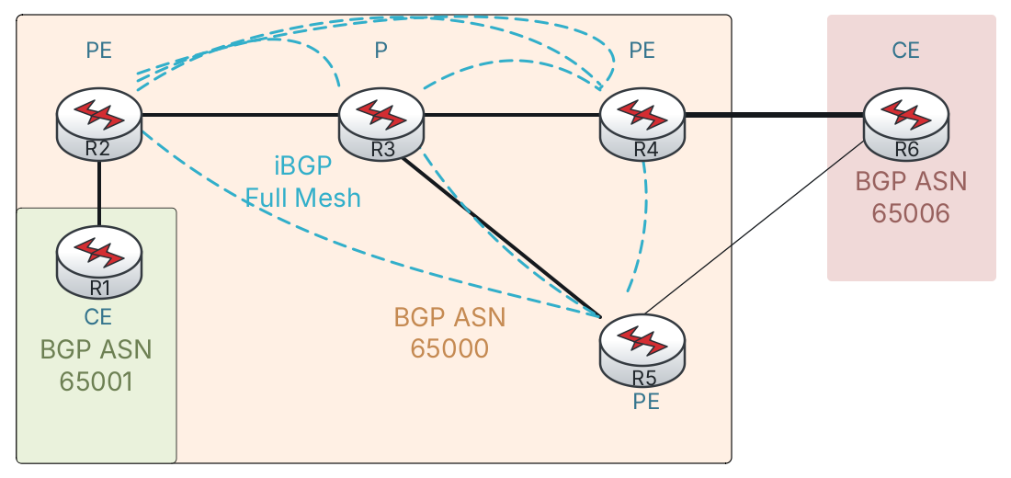
Figure 0-4 BGP Russo Lab 1 ECMP

Load Config
# R1 – R6
config replace unix:labconfigs/bgp.russo-lab1.cfg force

The idea behind these labs is that R6 is advertising 192.0.2.6/32 and 2001:db8::6/128. It is multi-homed to R4 and R5. We will use various techniques to achieve load balancing and failover.
This first lab requires you to configure ECMP.
Currently R2 and R3 are using R4 for egress due to its lower RID. R6 is using R4 for this reason as well.
Configure the fewest number of routers so that traffic from R1 to R6 is load balanced through R4 and R5, and return traffic from R6 is likewise load balanced.

Answer
# R3
router bgp 65000
address-family ipv4
maximum-paths ibgp 2
address-family ipv6
maximum-paths ibgp 2

# R6
router bgp 65006
address-family ipv4
maximum-paths 2
address-family ipv6
maximum-paths 2

Explanation
We do not need to enable iBGP multipath on R2, it will always use R3 to get to R4 and R5, so enabling multipath does not technically achieve anything. It can be done, but the result is the same with or without it.

R3#show bgp 192.0.2.6
% Command accepted but obsolete, unreleased or unsupported; see documentation.
BGP routing table entry for 192.0.2.6/32, version 3
Paths: (2 available, best #2, table default)
Not advertised to any peer
Refresh Epoch 1
65006
10.0.0.5 (metric 10) from 10.0.0.5 (10.0.0.5)
Origin IGP, metric 0, localpref 100, valid, internal
rx pathid: 0, tx pathid: 0
Updated on Oct 20 2026 06:16:26 UTC
Refresh Epoch 1
65006
10.0.0.4 (metric 10) from 10.0.0.4 (10.0.0.4)
Origin IGP, metric 0, localpref 100, valid, internal, best
rx pathid: 0, tx pathid: 0x0
Updated on Oct 20 2026 06:16:25 UTC

R3#
router bgp 65000
address-family ipv4
maximum-paths ibgp 2

R3#show ip bgp 192.0.2.6
BGP routing table entry for 192.0.2.6/32, version 4
Paths: (2 available, best #2, table default)
Multipath: iBGP
Not advertised to any peer
Refresh Epoch 1
65006
10.0.0.5 (metric 10) from 10.0.0.5 (10.0.0.5)
Origin IGP, metric 0, localpref 100, valid, internal, multipath(oldest)
rx pathid: 0, tx pathid: 0
Updated on Oct 20 2026 06:16:26 UTC
Refresh Epoch 1
65006
10.0.0.4 (metric 10) from 10.0.0.4 (10.0.0.4)
Origin IGP, metric 0, localpref 100, valid, internal, multipath, best
rx pathid: 0, tx pathid: 0x0
Updated on Oct 20 2026 06:16:25 UTC

R3#show ip route 192.0.2.6
Routing entry for 192.0.2.6/32
Known via "bgp 65000", distance 200, metric 0
Tag 65006, type internal
Last update from 10.0.0.4 00:00:23 ago
Routing Descriptor Blocks:
* 10.0.0.5, from 10.0.0.5, 00:00:23 ago
opaque_ptr 0x7F2E06A9E920
Route metric is 0, traffic share count is 1
AS Hops 1
Route tag 65006
MPLS label: none
10.0.0.4, from 10.0.0.4, 00:00:23 ago
opaque_ptr 0x7F2E06A9E920
Route metric is 0, traffic share count is 1
AS Hops 1
Route tag 65006
MPLS label: none

Russo – Lab 2 UCMP
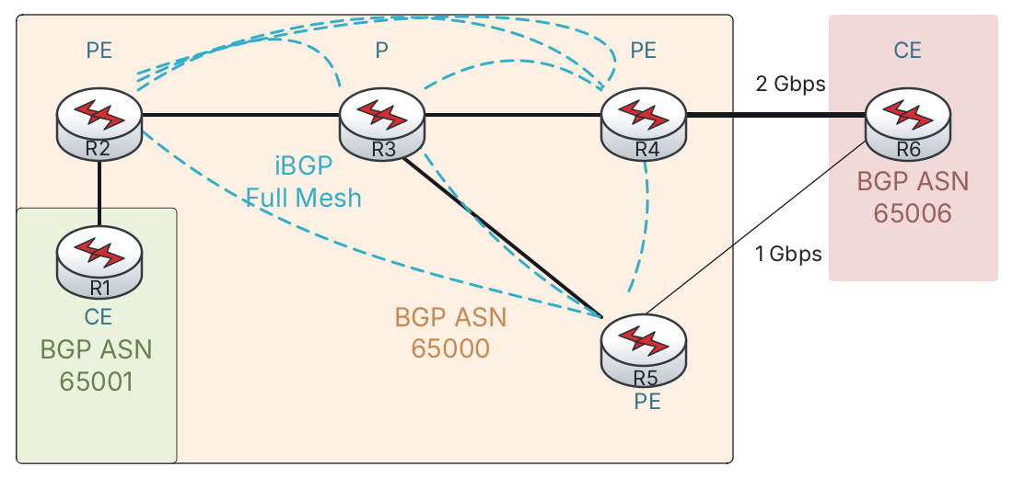
Figure 0-5 BGP Russo Lab 2 UCMP

Load Config
# R1 – R6
config replace unix:labconfigs/bgp.russo-lab2.cfg force
The bandwidth of the R4-R6 and R5-R6 link has been changed, matching the diagram above.
- Configure UCMP so that R3 will send twice as much traffic to R4.
- Additionally, configure R6 to send twice as much traffic to R4.
- Only do this for IPv4 traffic. (It doesn’t work for IPv6).

Answer
# R3
router bgp 65000
add ipv4
maximum-paths ibgp 2
bgp dmzlink-bw

# R4
router bgp 65000
template peer-policy IBGP_V4V6
send-community both
exit-peer-policy
add ipv4
bgp dmzlink-bw
neighbor 10.4.6.6 dmzlink-bw

# R5
router bgp 65000
template peer-policy IBGP_V4V6
send-community both
exit-peer-policy
add ipv4
bgp dmzlink-bw
neighbor 10.5.6.6 dmzlink-bw

# R6
router bgp 65006
add ipv4
bgp dmzlink-bw
neighbor 10.4.6.4 dmzlink-bw
neighbor 10.5.6.5 dmzlink-bw
maximum-paths 2

Explanation

R3#show ip bgp 192.0.2.6
BGP routing table entry for 192.0.2.6/32, version 7
Paths: (2 available, best #2, table default)
Multipath: iBGP
Not advertised to any peer
Refresh Epoch 9
65006
10.0.0.5 (metric 10) from 10.0.0.5 (10.0.0.5)
Origin IGP, metric 0, localpref 100, valid, internal, multipath(oldest)
DMZ-Link Bw 125000 kbytes
rx pathid: 0, tx pathid: 0
Updated on Oct 20 2026 06:39:18 UTC
Refresh Epoch 9
65006
10.0.0.4 (metric 10) from 10.0.0.4 (10.0.0.4)
Origin IGP, metric 0, localpref 100, valid, internal, multipath, best
DMZ-Link Bw 250000 kbytes
rx pathid: 0, tx pathid: 0x0
Updated on Oct 20 2026 06:39:08 UTC

R3#show ip route 192.0.2.6
Routing entry for 192.0.2.6/32
Known via "bgp 65000", distance 200, metric 0
Tag 65006, type internal
Last update from 10.0.0.4 00:00:12 ago
Routing Descriptor Blocks:
* 10.0.0.5, from 10.0.0.5, 00:00:12 ago
opaque_ptr 0x7F2E06A9E920
Route metric is 0, traffic share count is 1
AS Hops 1
Route tag 65006
MPLS label: none
10.0.0.4, from 10.0.0.4, 00:00:12 ago
opaque_ptr 0x7F2E06A9E920
Route metric is 0, traffic share count is 2
AS Hops 1
Route tag 65006
MPLS label: none

R6#show ip bgp 192.0.2.1
BGP routing table entry for 192.0.2.1/32, version 5
Paths: (2 available, best #2, table default)
Multipath: eBGP
Advertised to update-groups:
1
Refresh Epoch 8
65000 65001
10.5.6.5 from 10.5.6.5 (10.0.0.5)
Origin IGP, localpref 100, valid, external, multipath(oldest)
DMZ-Link Bw 125000 kbytes
rx pathid: 0, tx pathid: 0
Updated on Oct 20 2026 06:45:26 UTC
Refresh Epoch 7
65000 65001
10.4.6.4 from 10.4.6.4 (10.0.0.4)
Origin IGP, localpref 100, valid, external, multipath, best
DMZ-Link Bw 250000 kbytes
rx pathid: 0, tx pathid: 0x0
Updated on Oct 20 2026 06:45:26 UTC

R6#show ip route 192.0.2.1
Routing entry for 192.0.2.1/32
Known via "bgp 65006", distance 20, metric 0
Tag 65000, type external
Last update from 10.4.6.4 00:01:02 ago
Routing Descriptor Blocks:
* 10.5.6.5, from 10.5.6.5, 00:01:02 ago
opaque_ptr 0x7F1FD17E3530
Route metric is 0, traffic share count is 1
AS Hops 2
Route tag 65000
MPLS label: none
10.4.6.4, from 10.4.6.4, 00:01:02 ago
opaque_ptr 0x7F1FD17E3530
Route metric is 0, traffic share count is 2
AS Hops 2
Route tag 65000
MPLS label: none

Russo – Lab 3 Backup Path
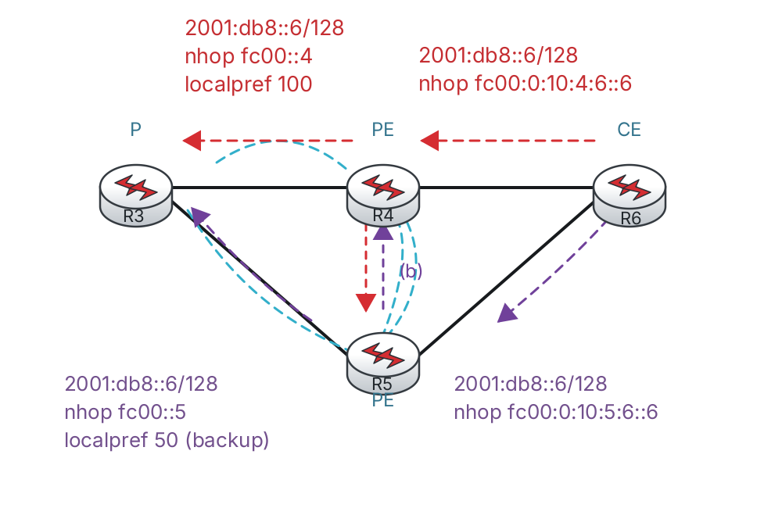

Load Config
# R1 – R6
config replace unix:labconfigs/bgp.russo-lab3.cfg force

R5 is setting Local Preference to 50 on routes received from R6.
Configure the core so that R4 is always used as the primary path, but if that path is lost, the core will immediately re-route to using R5.

Answer
#R5
router bgp 65000
add ipv4
bgp advertise-best-external
add ipv6
bgp advertise-best-external

#R2, R3, R4
router bgp 65000
add ipv4
bgp additional-paths install
add ipv6
bgp additional-paths install

Explanation
Before making any changes, notice that R5 is hiding its external path. This is because its iBGP path via R4 is better than its eBGP path due to local preference. On R3, we only see R4’s path to R6’s prefixes.

# r5
R5#show ip bgp
Network Next Hop Metric LocPrf Weight Path
*>i 192.0.2.1/32 10.0.0.2 0 100 0 65001 i
*>i 192.0.2.6/32 10.0.0.4 0 100 0 65006 i
* 10.5.6.6 0 50 0 65006 i

R5#show bgp ipv6 unicast
Network Next Hop Metric LocPrf Weight Path
*>i 2001:DB8::1/128 FC00::2 0 100 0 65001 i
*>i 2001:DB8::6/128 FC00::4 0 100 0 65006 i
* FC00:10:5:6::6 0 50 0 65006 i

First we must configure R5 to advertise its external path. We can either use Add Path, or simply use the advertise-best-external feature. This allows R5 to advertise its eBGP path even when the iBGP path is best, and does not require Add Path.

# r5
router bgp 65000
add ipv4
bgp advertise-best-external
add ipv6
bgp advertise-best-external

R5#show bgp ipv4 unicast
BGP table version is 10, local router ID is 10.0.0.5
Status codes: s suppressed, d damped, h history, * valid, > best, i - internal,
r RIB-failure, S Stale, m multipath, b backup-path, f RT-Filter,
x best-external, a additional-path, c RIB-compressed,
t secondary path, L long-lived-stale,
Origin codes: i - IGP, e - EGP, ? - incomplete
RPKI validation codes: V valid, I invalid, N Not found

Network Next Hop Metric LocPrf Weight Path
*>i 192.0.2.1/32 10.0.0.2 0 100 0 65001 i
*>i 192.0.2.6/32 10.0.0.4 0 100 0 65006 i
*b x 10.5.6.6 0 50 0 65006 i

R5#show bgp ipv6 unicast
BGP table version is 15, local router ID is 10.0.0.5
Status codes: s suppressed, d damped, h history, * valid, > best, i - internal,
r RIB-failure, S Stale, m multipath, b backup-path, f RT-Filter,
x best-external, a additional-path, c RIB-compressed,
t secondary path, L long-lived-stale,
Origin codes: i - IGP, e - EGP, ? - incomplete
RPKI validation codes: V valid, I invalid, N Not found

Network Next Hop Metric LocPrf Weight Path
*>i 2001:DB8::1/128 FC00::2 0 100 0 65001 i
*>i 2001:DB8::6/128 FC00::4 0 100 0 65006 i
*b x FC00:10:5:6::6 0 50 0 65006 i

R3#show bgp ipv6 uni
R3#show bgp ipv6 unicast | begin Network
Network Next Hop Metric LocPrf Weight Path
*>i 2001:DB8::1/128 FC00::2 0 100 0 65001 i
* i 2001:DB8::6/128 FC00::5 0 50 0 65006 i
*>i FC00::4 0 100 0 65006 i
R3#show bgp ipv4 unicast | begin Network
Network Next Hop Metric LocPrf Weight Path
*>i 192.0.2.1/32 10.0.0.2 0 100 0 65001 i
* i 192.0.2.6/32 10.0.0.5 0 50 0 65006 i
*>i 10.0.0.4 0 100 0 65006 i
R3#show bgp ipv4 unicast 192.0.2.6
BGP routing table entry for 192.0.2.6/32, version 11
Paths: (2 available, best #2, table default)
Flag: 0x100
Not advertised to any peer
Refresh Epoch 1
65006
10.0.0.5 (metric 10) from 10.0.0.5 (10.0.0.5)
Origin IGP, metric 0, localpref 50, valid, internal
rx pathid: 0, tx pathid: 0
Updated on Oct 20 2026 09:10:33 UTC
Refresh Epoch 2
65006
10.0.0.4 (metric 10) from 10.0.0.4 (10.0.0.4)
Origin IGP, metric 0, localpref 100, valid, internal, best
rx pathid: 0, tx pathid: 0x0
Updated on Oct 20 2026 09:10:30 UTC

We need to tell R2, R3, and R4 to install additional paths as repair paths in the FIB.
# r3, r2, r4
router bgp 65000
add ipv4
bgp additional-paths install
add ipv6
bgp additional-paths install

R3#show bgp ipv4 unicast 192.0.2.6/32
BGP routing table entry for 192.0.2.6/32, version 13
Paths: (2 available, best #2, table default)
Additional-path-install
Not advertised to any peer
Refresh Epoch 2
65006
10.0.0.5 (metric 10) from 10.0.0.5 (10.0.0.5)
Origin IGP, metric 0, localpref 50, valid, internal, backup/repair
rx pathid: 0, tx pathid: 0
Updated on Oct 20 2026 09:24:43 UTC
Refresh Epoch 3
65006
10.0.0.4 (metric 10) from 10.0.0.4 (10.0.0.4)
Origin IGP, metric 0, localpref 100, valid, internal, best
rx pathid: 0, tx pathid: 0x0
Updated on Oct 20 2026 09:24:43 UTC

R3#show ip cef 192.0.2.6
192.0.2.6/32
nexthop 10.3.4.4 Ethernet0/1.34

R3#show ip cef 192.0.2.6 detail
192.0.2.6/32, epoch 0, flags [rib only nolabel, rib defined all labels]
recursive via 10.0.0.4
nexthop 10.3.4.4 Ethernet0/1.34
recursive via 10.0.0.5, repair
nexthop 10.3.5.5 Ethernet0/1.35

Russo – Lab 4 Shadow Session
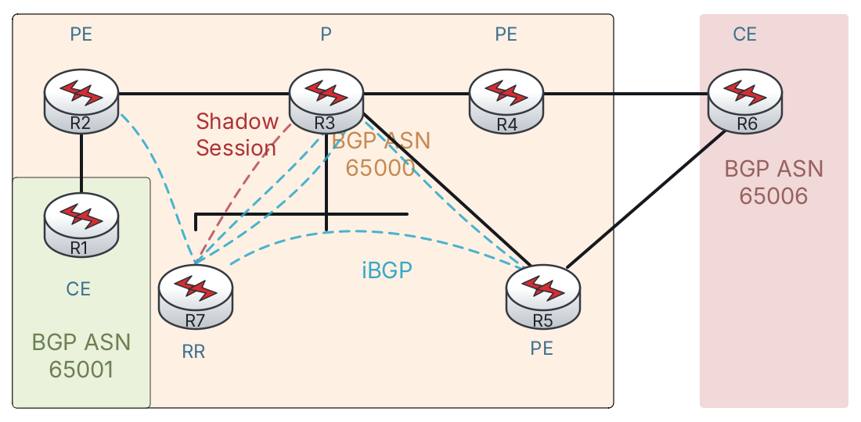

Load Config
# R1 – R6
config replace unix:labconfigs/bgp.russo-lab3.cfg force

R7 has been introduced as the RR. This causes the path to R6’s loopbacks via R5 to be hidden again.
Create a shadow session between R3 and R7 so that R3 learns both paths (via R4 and via R5). Enable multipath on R3. New loopbacks (Lo1) have been preconfigured on R3 and R7 for this shadow session.
- R3 Lo1 = 10.0.0.33, fc00::33
- R7 Lo1 = 10.0.0.77, fc00::77

Answer

# R3
router bgp 65000
template peer-session IBGP_SESS_SHADOW
remote-as 65000
update-source Loopback1
!
neighbor 10.0.0.77 inherit peer-session IBGP_SESS_SHADOW
neighbor FC00::77 inherit peer-session IBGP_SESS_SHADOW
!
address-family ipv4
neighbor 10.0.0.77 activate
maximum-paths ibgp 2
!
address-family ipv6
maximum-paths ibgp 2
neighbor FC00::77 activate
# R7
router bgp 65000
!
template peer-session IBGP_SESS_SHADOW
remote-as 65000
update-source Loopback1
!
neighbor 10.0.0.33 inherit peer-session IBGP_SESS_SHADOW
neighbor FC00::33 inherit peer-session IBGP_SESS_SHADOW
!
address-family ipv4
bgp additional-paths select backup
neighbor 10.0.0.33 activate
neighbor 10.0.0.33 inherit peer-policy IBGP_V4V6
neighbor 10.0.0.33 advertise diverse-path backup
exit-address-family
!
address-family ipv6
bgp additional-paths select backup
neighbor FC00::33 activate
neighbor FC00::33 inherit peer-policy IBGP_V4V6
neighbor FC00::33 advertise diverse-path backup
exit-address-family

Explanation
Before we make the change, notice that R7 is hiding the backup path via R5. By default, the RR only sends its bestpath to all RR clients.
The RR advertises the “diverse-path backup” path on the shadow session, not the bestpath. This does not require Add Path to be configured and negotiated between peers. It is similar to advertise-best-external in a way.
Also note that R7 does not need to locally install the backup path as a fast repair route, as it will not be in the data path.

R7#show bgp ipv4 unicast neighbors 10.0.0.33 advertised-routes
BGP table version is 5, local router ID is 10.0.0.7
Status codes: s suppressed, d damped, h history, * valid, > best, i - internal,
r RIB-failure, S Stale, m multipath, b backup-path, f RT-Filter,
x best-external, a additional-path, c RIB-compressed,
t secondary path, L long-lived-stale,
Origin codes: i - IGP, e - EGP, ? - incomplete
RPKI validation codes: V valid, I invalid, N Not found

Network Next Hop Metric LocPrf Weight Path
*>i 192.0.2.1/32 10.0.0.2 0 100 0 65001 i
*bia 192.0.2.6/32 10.0.0.5 0 100 0 65006 i

R3#show bgp ipv4 unicast 192.0.2.6
BGP routing table entry for 192.0.2.6/32, version 8
Paths: (2 available, best #2, table default)
Multipath: iBGP
Not advertised to any peer
Refresh Epoch 2
65006
10.0.0.5 (metric 10) from 10.0.0.77 (10.0.0.7)
Origin IGP, metric 0, localpref 100, valid, internal, multipath(oldest)
Originator: 10.0.0.5, Cluster list: 10.0.0.7
rx pathid: 0, tx pathid: 0
Updated on Oct 24 2026 07:16:32 UTC
Refresh Epoch 1
65006
10.0.0.4 (metric 10) from 10.0.0.7 (10.0.0.7)
Origin IGP, metric 0, localpref 100, valid, internal, multipath, best
Originator: 10.0.0.4, Cluster list: 10.0.0.7
rx pathid: 0, tx pathid: 0x0
Updated on Oct 24 2026 07:16:32 UTC

